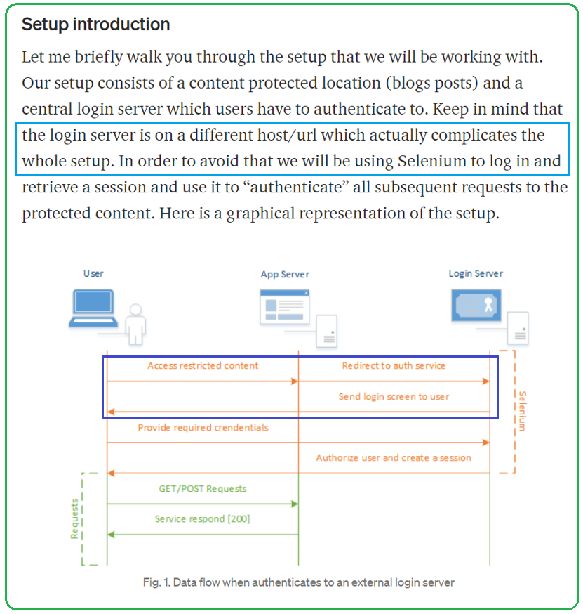

An **HTTP cookie** (web cookie, browser cookie) is a small piece of data that a server sends to a user's web browser. The browser may store the cookie and send it back to the same server with later requests. Typically, an HTTP cookie is used to tell if two requests come from the same browser—keeping a user logged in, for example. It remembers stateful information for the [stateless](https://developer.mozilla.org/en-US/docs/Web/HTTP/Overview#http_is_stateless_but_not_sessionless) HTTP protocol.

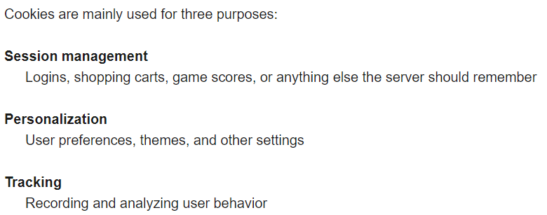

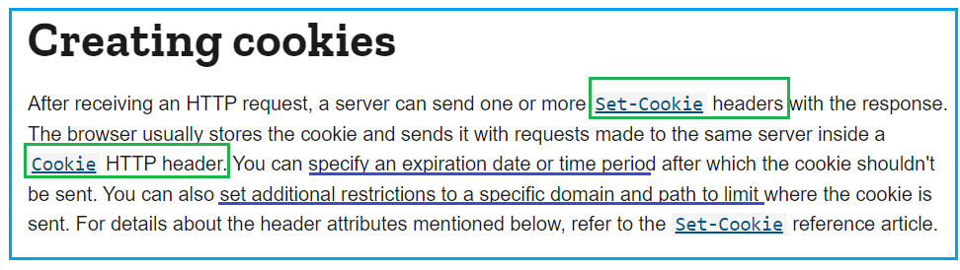

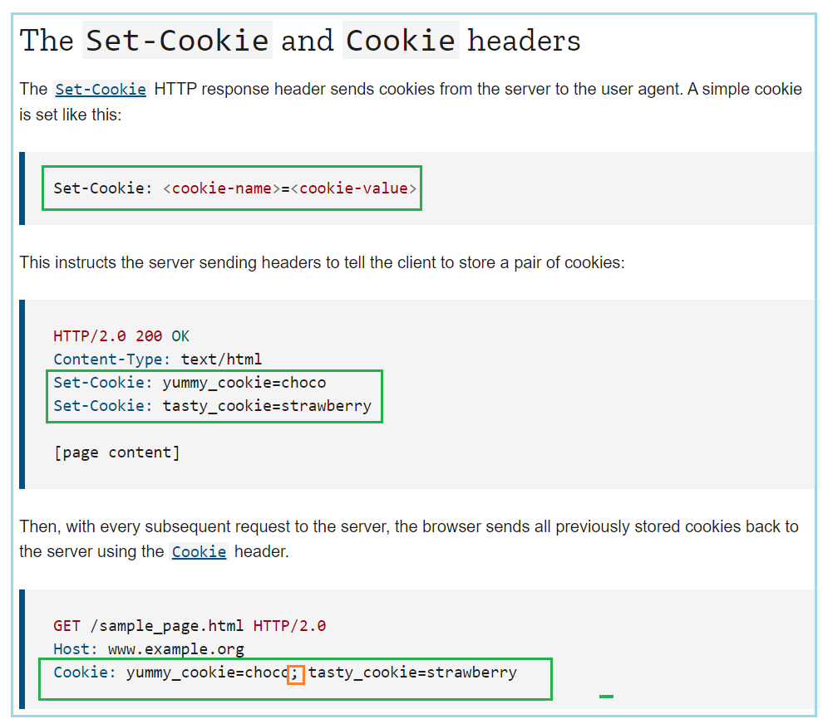

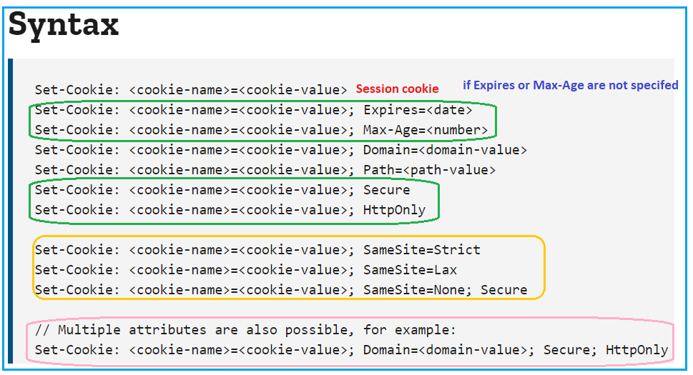

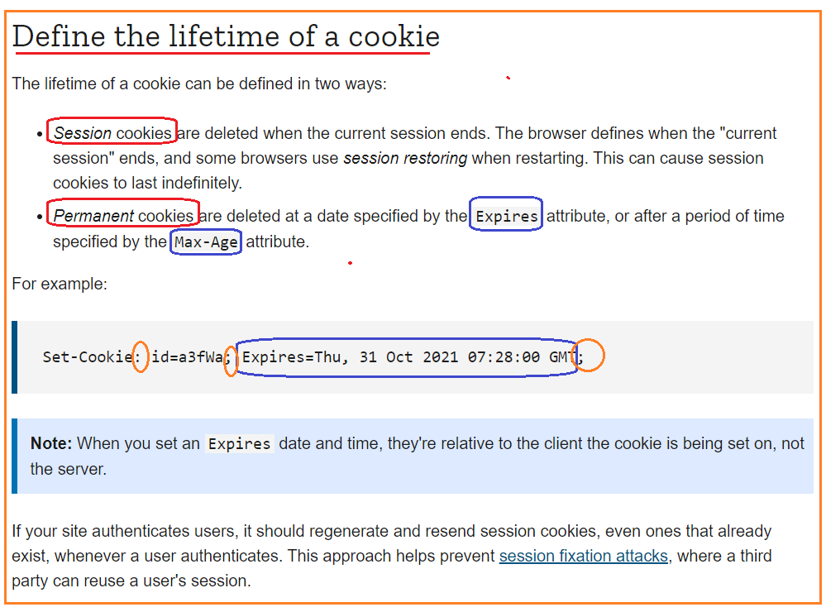

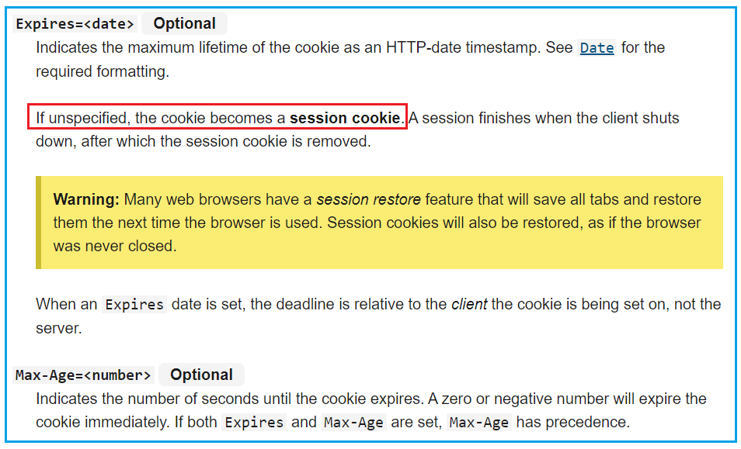

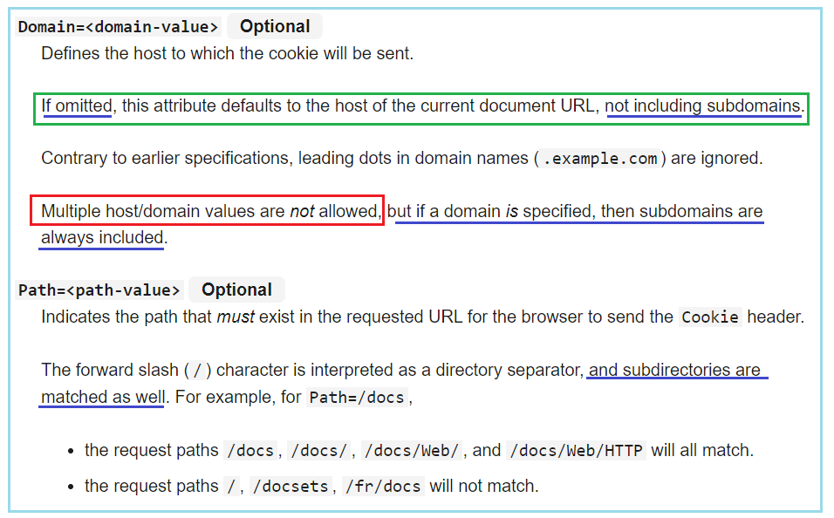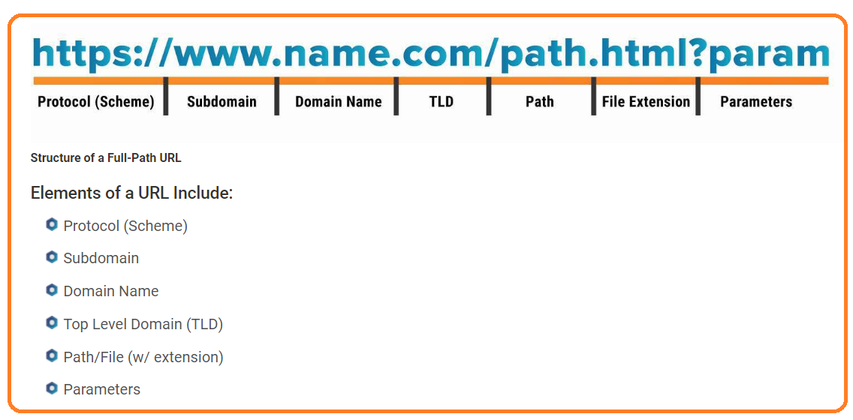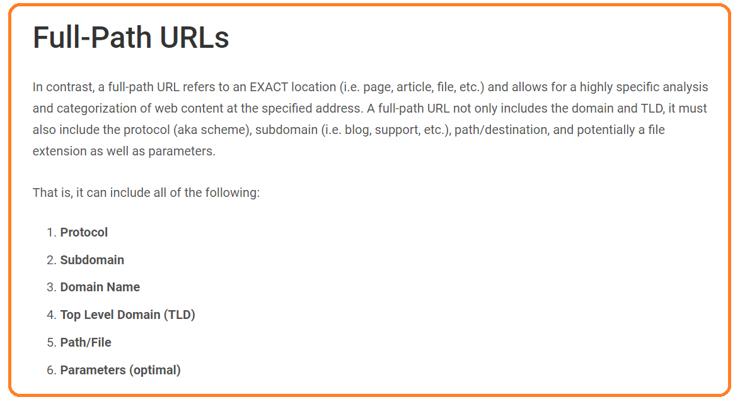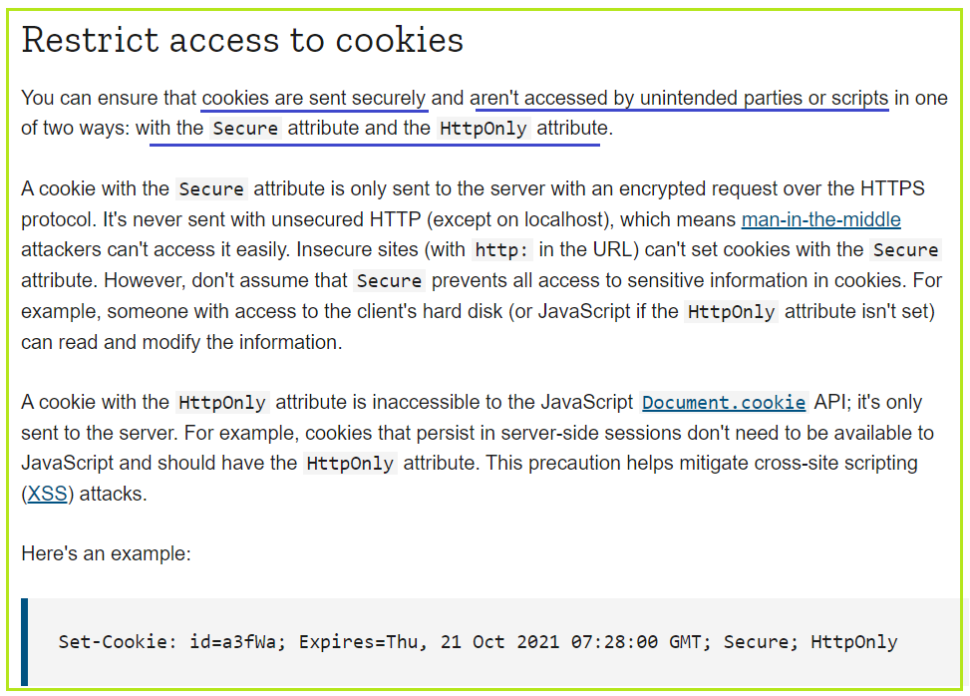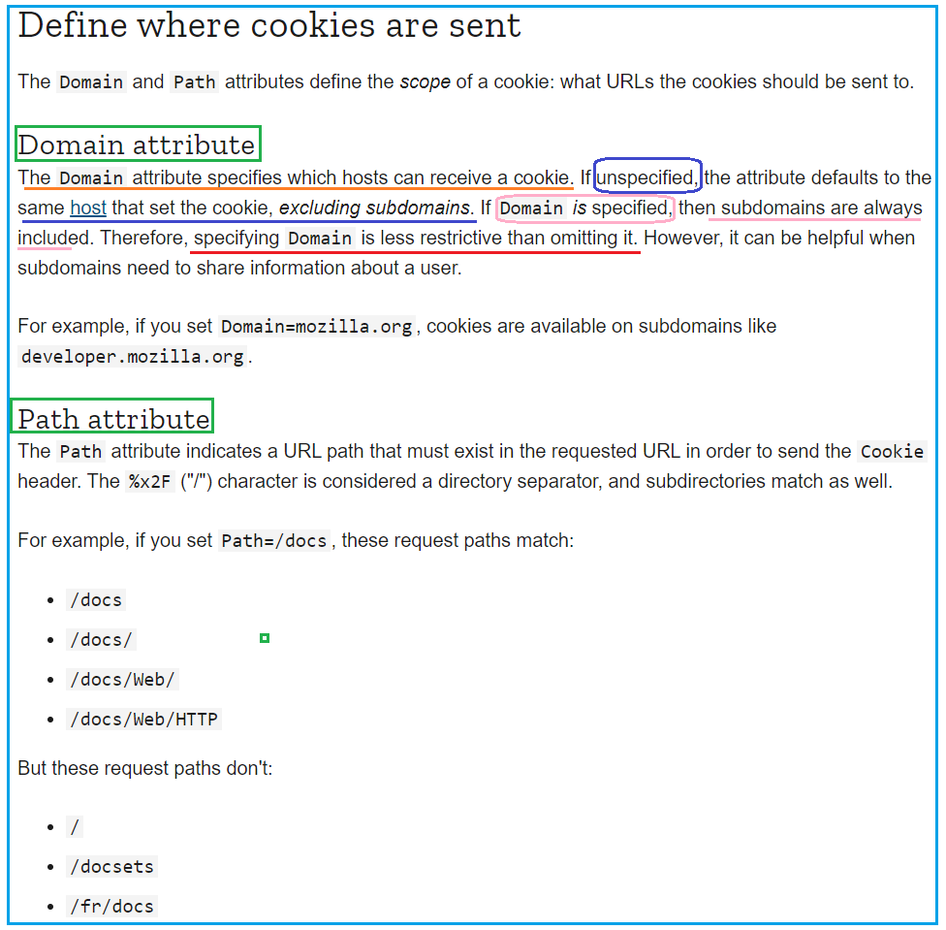

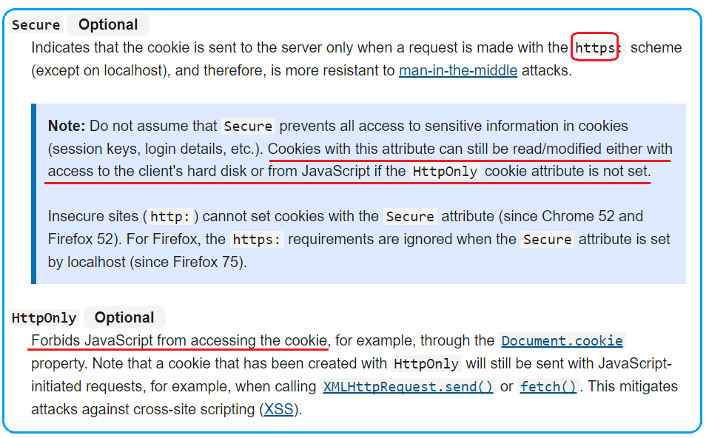

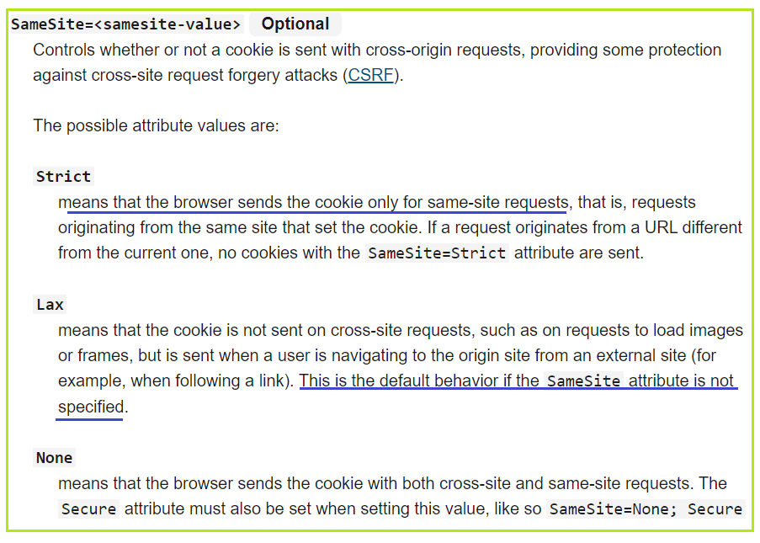 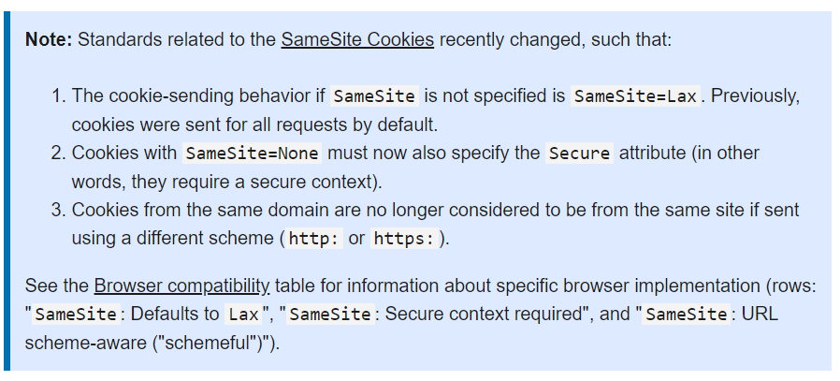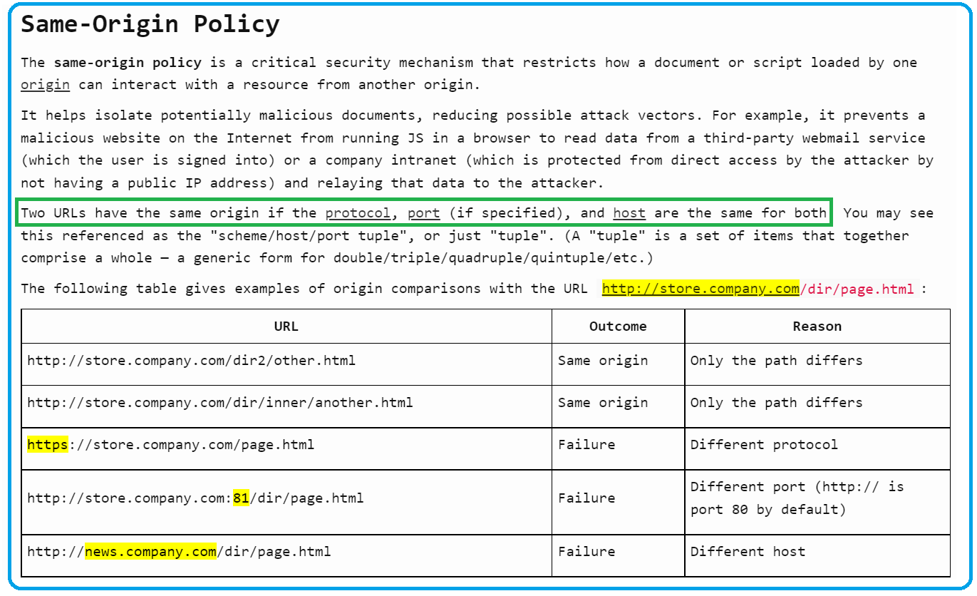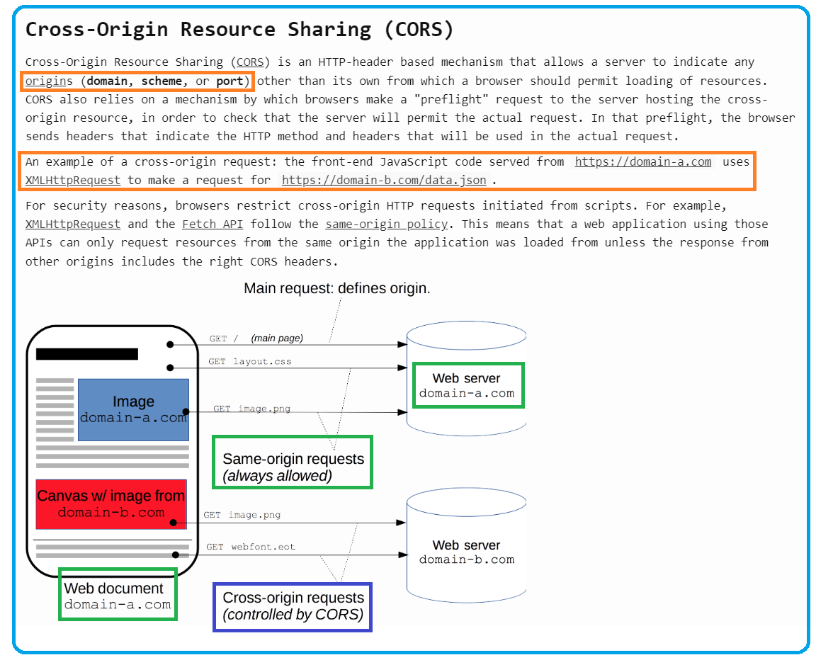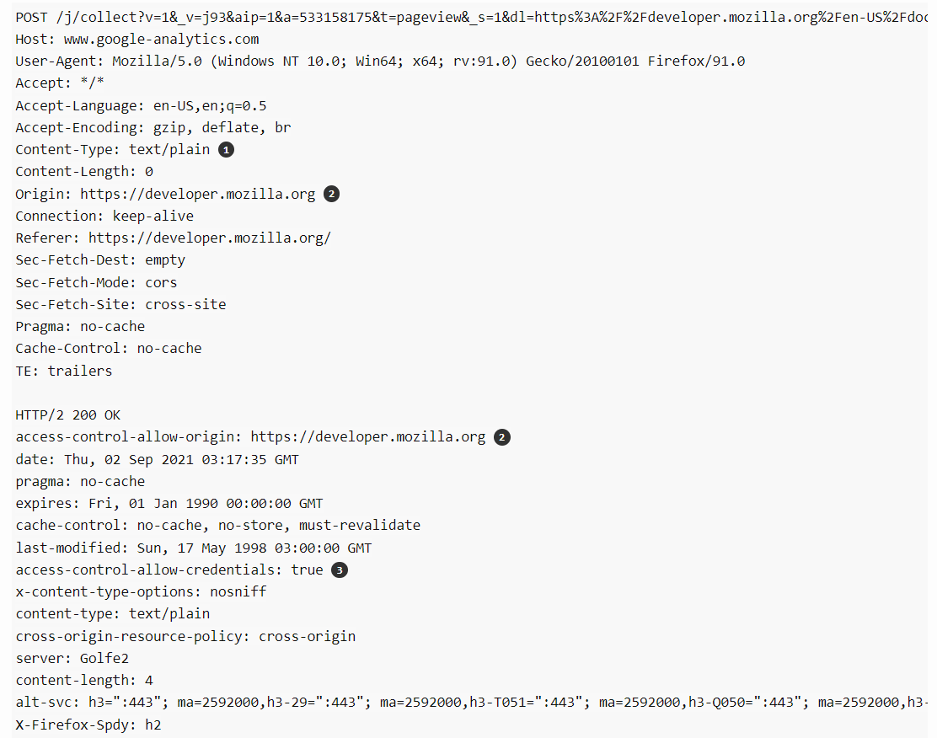

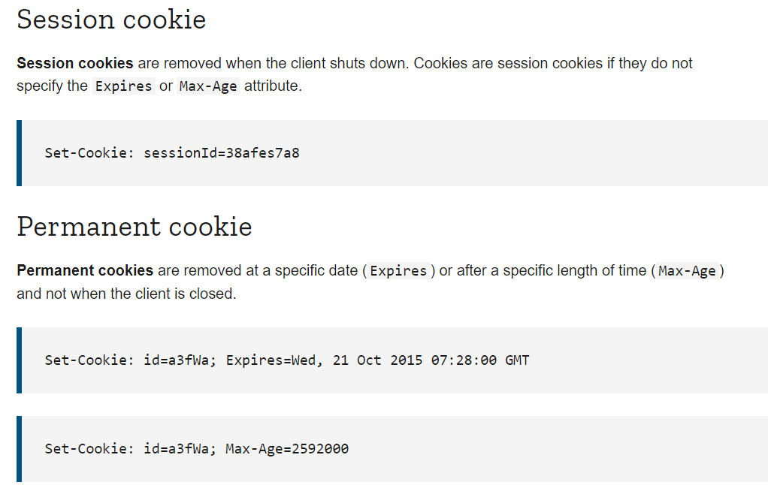

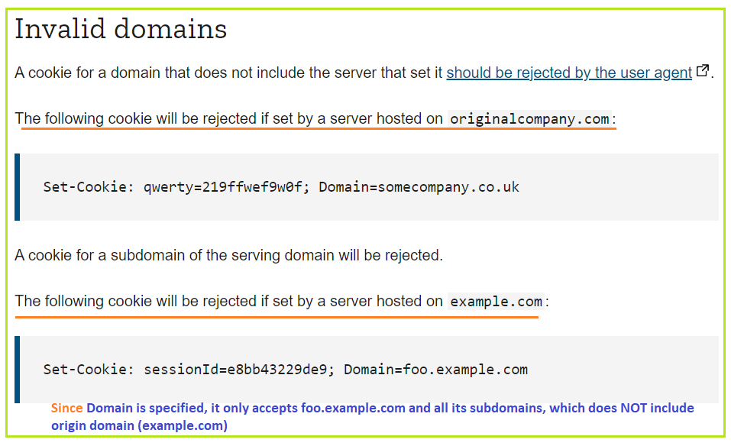

1. **If Cookies are used to maintain state between client and server**
2. **Does server save cookies?**

**NO**, server dose NOT save cookies in server-side. All the cookies are sent to client (browser)

Browser saves **session cookies** in memory.

Browser saves **persistent cookies** in cookie files **per domain** per with expiration.

1. How did server keep track of expiration of each cookies.

Server **Does NOT** keep track of expiration of cookies. **Browser is responsible for not sending any expired cookies to server**.

Cookies on client side have expiry date and time value associated with it. After the specified date & time, browser will not honor that cookie and will skip that cookie in further HTTP(s) requests.

The browser is responsible for managing cookies, and the cookie's expiration time and date help the browser manage its store of cookies. When the browser sends cookie information to the server, the browser does not include the expiration information. (The cookie's Expires property always returns a date-time value of zero.)

You can read the Expires property of a cookie from HttpResponse object, before the cookie has been sent to the browser. **However, you cannot get the expiration back in the HttpRequest object.**

1. **How does server validate cookies sent from browser**

Cookies can always be edited by the client. Client can send back modified cookies or even client created cookies to server. Server has no control of what kinda cookies it will receive.

How server treat received cookies are implementation-dependent.

Server can have its’ own routine to create cookies and so have its expectations of what kind of cookies it is capable of handling. For cookies it can’t handle, it can choose to ignore, delete, or issue 400 bad request. We can't trust cookie’s value for time sensitive tasks. For example, session id will have timestamp associated with it only in encrypted format so that people can’t tamper it.

You **cannot directly modify a cookie**. Instead, changing a cookie consists of creating a new cookie with new values and then sending the cookie to the browser to overwrite the old version on the client.

**-----------------------------------------**

If the user is accessing the same web page or application **from two different browsers** or **separate instances of the same browser** then the session cookies generated will be different for each one.

If you are using a single browser with multiple tabs then **all the tabs share the same Session Cookie**.

**Creating sessions on server**

The basic principle behind sessions is that a server maintains information for every single client, and clients rely on **unique session id's** to access this information. When users visit the web application, the server will create a new session with the following three steps, as needed:

* Create a unique session id
* Open up a data storage space: normally we **save sessions in memory**, but you will lose all session data if the system is accidentally interrupted. This can be a very serious issue if web application deals with sensitive data, like in electronic commerce for instance. In order to solve this problem, you can instead save your session data in a **database or file system**. This makes data persistence more reliable and easy to share with other applications, although the tradeoff is that more **server-side IO** is needed to read and write these sessions.
* Send the unique session id to the client.

The key step here is to send the unique session id to the client. In the context of a standard HTTP response, you can either use the response line, header or body to accomplish this; therefore, we have **two ways to send session ids to clients: by cookies or URL rewrites**.

* Cookies: the server can easily use **Set-cookie** inside of a response header to send a session id to a client, and a client can then use this cookie for future requests; we often set the expiry time for cookies containing session information to 0, which means the cookie will be saved in memory and only deleted after users have close their browsers.
* **URL rewrite**: append the session id as arguments in the URL for all pages. This way seems messy, but it's the best choice if clients have disabled cookies in their browsers.

Cookies are small key/value pairs stored by a server on the client computer. They are often used to track visitors and maintain sessions.

* **web** servers instruct the client to store a cookie by issuing a special HTTP header, "**Set-Cookie**".
* once cookied, every subsequent request by the client to that server will include the **HTTP header**, "Cookie" with the data that was stored.
* by default, cookies are deleted when the user quits the browser. However, the server can instruct the client to keep them longer.

The following example shows how the server can read the value of a cookie and **use it to determine the content of the web page that is sent to the client.**

* # !/usr/local/pkg/python/3.5/bin/python3  
    
  import os  
    
  print("Content-type: text/html")  
  print()  
    
  c = {} # blank dictionary of cookies  
    
  # check for cookies in the operating system's environmental variables  
  if "**HTTP_COOKIE**" in os.environ:  
   # the os module stores cookies as a semi-colon separated string of key=value pairs  
   cookie_list = os.environ["HTTP_COOKIE"].split(";")  
   for cookie_string in cookie_list:  
   # separate the key from the value  
   key, value = cookie_string.split('=')  
   c[key.strip()] = value.strip()  
    
  # output the HTML  
    
  print('''  
   <nowiki>  
   <!doctype html>  
   <html>  
   <head>  
   <title>Get Cookie Values</title>  
   </head>  
   <body>  
   <h1>Get Cookie Values</h1>  
   ''')  
    
  if c.get('has_visited_before', '') == 'yes':  
   print('''  
   <p>  
   Your unique ID is {uid}  
   <br />  
   You've been here before!  
   </p>  
   '''.format(uid=c.get('unique_id', '')))  
    
  else:  
   print('''  
   <p>Welcome for the first time!</p>  
   ''')  
    
  print('''   
   </body>  
   </html>  
   ''')

The following Python code shows **how the server can tell the client to store a few cookies on its behalf**.

#!/usr/local/pkg/python/3.5/bin/python3  
  
import random  
import datetime, time  
from http import cookies  
  
# make a blank cookie object  
c = cookies.SimpleCookie()  
  
# set some cookies  
random_id = random.randint(0, 1000000000) + int(time.time()) # generate a random id  
c["unique_id"] = random_id # tell the browser to store a cookie  
c["has_visited_before"] = "yes" # tell the browser to store a cookie  
  
# set a cookie with a custom expiration date.. this cookie will self-destruct in year  
expiration = datetime.datetime.now() + datetime.timedelta(days=365)  
c["semi-permanent-cookie"] = "here it is"  
c["semi-permanent-cookie"]["expires"] = expiration.strftime("%a, %d-%b-%Y %H:%M:%S EST")  
  
print("Content-type: text/html;charset=utf-8")  
print(c) # output the Set-Cookie HTTP response header  
print("\n")

To delete a cookie, simply **set its expiration date to a time in the past**.

#!/usr/local/pkg/python/3.5/bin/python3  
  
import datetime, time  
from http import cookies  
  
# make a blank cookie object  
c = cookies.SimpleCookie()  
  
# set a cookie with an already-passed expiration date.. this cookie will self-destruct immediately  
expiration = datetime.datetime.now() + datetime.timedelta(days=-1)  
c["semi-permanent-cookie"] = "here it is"  
c["semi-permanent-cookie"]["expires"] = expiration.strftime("%a, %d-%b-%Y %H:%M:%S EST")  
  
print("Content-type: text/html;charset=utf-8")  
print(c) # output the Set-Cookie HTTP response header  
print("\n")

**Cookies are saved by browser on client side in cookie file, based on domain name.**

HTTP/1.1 200 OK ﻿

Content-Type: text/html; charset=utf-8

Date: Thu, 13 Oct 2016 16:03:41 GMT

**Set-Cookie:** RMID=007f010109ee57ff1a960007; path=/; domain=.nytimes.com; expires=Fri, 13 Oct 2017 05:24:38 UTC

GET / HTTP/1.1

Host: www.nytimes.com

**Cookie:** RMID=007f010109ee57ff1a960007**;**

User-Agent: Mozilla/5.0 (Windows NT 10.0; WOW64) AppleWebKit/537.36 (KHTML, like Gecko) Chrome/53.0.2785.143 Safari/537.36

1. **Cookie mechanism**

**Step 1: Client > Signing up (HTTP POST)**

Before anything else, the user has to sign up. The client **posts a HTTP request** to the server containing his/her username and password.

**Step 2: Server > Handling sign up**

The server receives this request and **hashes** the password before storing the username and password in database. This way if someone gains access to your database they won't see your users' actual passwords.

**Step 3: Client > User login (HTTP POST)**

Now your user **logs in**. provides their username/password and again, **HTTP POST** request to log in the server.

**Step 4: Server > Validating login**

The **server looks up the username in the database**, hashes the supplied login password, and compares it to the previously hashed password in the database. If it doesn't match, we may deny them access by [sending a **401 (Not authorized)** status code and ending the request](https://stackoverflow.com/questions/1959947/whats-an-appropriate-http-status-code-to-return-by-a-rest-api-service-for-a-val).

**Step 5: Server > Generating access token**

If everything checks out, we're going to create an access token, which uniquely identifies the user's session. Still in the server, we do two things with the **access token**:

1. **Store it in the database associated with that user**
2. **Attach it to a response cookie** to be returned to the client. Be sure to set an expiration date/time to limit the user's session

Henceforth, the cookies will be attached to every request (and response) made between the client and server.

**Cookies contains access token; sever saves access token in DB associated with user.**

**Cookies contains session id or user id**: server creates a session ID as user identifier, and **store Session ID in DB**

1. After the request is made, the server validate the user on the backend by querying in the database. If the request is valid, it will create a session by using the user information fetched from the database and store them, for each session a unique id called **session Id** is created ,by default session Id will be given to client through the Browser.
2. **Browser will submit this session Id** **on each subsequent requests**, the session ID is verified against the database, based on this session id website will identify the session belonging to which client and then give access the request.

**Step 6: Client > Making page requests**

Back on the client side, we are now logged in. Every time the client makes a request for a page that requires authorization (i.e. they need to be logged in), **the server obtains the access token from the cookie** and checks it against the one in the database associated with that user. If it checks out, access is granted.

This should get you started. Be sure to clear the cookies upon logout!

**SSL** secures interception during requests/responses, but an attacker might access your cookies at the client side (e.g. your browser). Theoretically, they could then pose as a logged in user until the cookie expires. I say “theoretically” because the implementation above doesn’t handle that. In the above implementation, (i.e. next login).

you could along with the token/session key also **save the user's ip address** along with other identifying parameters such as user-agent, etc. if the request then comes with a valid cookie but from the wrong ip, browser, etc then you deny the request and redirect the user to the login page to authenticate again.

1. **Cookie size and quantity limitation**

* **For each Domain, up to 4 KB /cookie, and 20 cookies**
* **For whole browser, up to 300 cookies.**

1. **Cookie Generation**

* *By server:* The **Set-cookie response header** from the server directs the client to set a cookie on that particular domain. **The implementation to actually create and store the cookie lies in the browser**. For subsequent requests to the same domain, the browser automatically sets the Cookie request header for each request, thereby letting the server have some state to an otherwise stateless HTTP protocol. The **Domain and Path** cookie attributes are used by the browser to determine which cookies are to be sent to a server. **The server only receives name=value pairs, and nothing more**.
* ***By Client****:* One can create a cookie on the browser using **javascript** document.cookie = cookiename=cookievalue. However, **if the server does not intend to respond to any random cookie a user creates, then such a cookie serves no purpose**.
* Cookies always belong to the client. There is no such thing as server side cookie.
* On the client side, by setting the HttpOnly attribute of the cookie, it is possible to **prevent scripts ( mostly Javscript ) from reading your cookies** , thereby acting as a defense mechanism against Cookie theft through XSS, but sends the cookie to the intended server only.
* Therefore, in most of the cases since cookies are used to **bring 'state'** ( memory of past user events ), **creating cookies on client side does not add much value**, unless one is aware of the cookies the server uses / responds to.

1. **Cookies contents**

When a developer creates a cookie, with the function **setcookie**, he must specify at least three arguments. These arguments are setcookie (**name**, **value**, **expiration**);

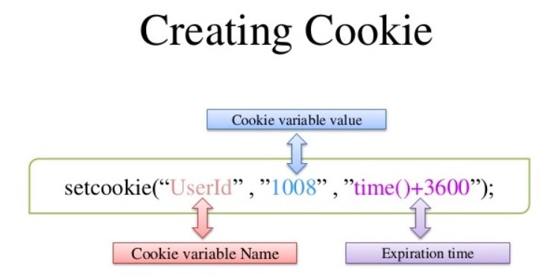

1. **Cookie Attribute**
2. **Name:** Specifies the name of the cookie
3. **Value:** Specifies the value of the cookie
4. **Secure:** Specifies whether or not the cookie should only be transmitted over a **secure HTTPS** connection. TRUE indicates that the cookie will only be set if a secure connection exists. Default is FALSE
5. **Domain:** Specifies the domain name of the cookie. To make the cookie available on all subdomains of example.com, set the domain to “example.com”. Setting it to www.example.com will make the cookie only available in the www subdomain
6. **Path:** Specifies the server path of the cookie. **If set to “/”, the cookie will be available within the entire domain**. If set to “/php/”, the cookie will only be available within the php directory and all sub-directories of php. The default value is the current directory that the cookie is being set in

* Explanation: Domain and Path

**The domain option**

* The next option is domain, which indicates the domain(s) for which the cookie should be sent. By default, domain is set to the **host name** of the page setting the cookie, so the cookie value is sent whenever a request is made to the same host name. For example, the default domain for a cookie set on this site would be [www.nczonline.net](http://www.nczonline.net/). The domain option is used to widen the number of domains for which the cookie value will be sent. Sample:
* Set-Cookie: name=Nicholas; domain=nczonline.net
* Consider the case of a large network such as [Yahoo!](http://www.yahoo.com/) that has many sites in the form of *name*.[yahoo.com](http://yahoo.com/) (e.g., [my.yahoo.com](http://my.yahoo.com/), [finance.yahoo.com](http://finance.yahoo.com/), etc.). A single cookie value can be set for all of these sites by setting the domain option to simply [yahoo.com](http://yahoo.com/). The browser performs a **tail comparison** of **this value** and **the host name** to which a request is sent (meaning it starts the comparison from the end of the string) and sends the corresponding Cookie header when there’s a match.
* The value set for the domain option must be part of the host name that is sending the Set-Cookie header. I couldn’t, for example, set a cookie on [google.com](http://www.google.com/) because that would introduce a security issue. Invalid domain options are simply ignored.

**The path option**

* Another way to control when the Cookie header will be sent is to specify the path option. Similar to the domain option, path indicates a URL path that must exist in the requested resource before sending the Cookie header. This comparison is done by comparing the option value character-by-character against the start of the request URL. If the characters match, then the Cookie header is sent. Sample:
* Set-Cookie: name=Nicholas; path=/blog
* In this example, the path option would match /blog, /blogroll, etc.; anything that begins with /blog is valid. **Note that this comparison is only done once the domain option has been verified**. The default value for the path option is the path of the URL that sent the Set-Cookie header.

1. **HTTPOnly:** If set to TRUE the cookie will be accessible only through the HTTP protocol (the cookie will not be accessible by scripting languages). This setting can help to reduce identity theft through XSS attacks. Default is FALSE
2. **Expires:** Specifies when the cookie expires. The value: time ()+86400*30, will set the cookie to expire in 30 days. If **this parameter is omitted** or **set to 0**, the cookie will expire **at the end of the session (when the browser closes)**. Default is 0

If a cookie has both the Max-Age and the Expires attribute, the **Max-  
Age attribute has precedence** and controls the expiration date of the cookie. **If a cookie has neither the Max-Age nor the Expires attribute, the user agent will retain the cookie until "the current session is over"**

To change the "expiry" of a cookie from the server, a Set-Header must be sent again with:

* the same cookie name
* the same Domain parameter value
* the same Path parameter value
* a different Expires or Max-Age attribute

But note that if the HttpOnly parameter is not set (or not supported by the browser), **the cookie value and parameters can be modified by JavaScript**.  
see: [JavaScript - Cookies](http://www.quirksmode.org/js/cookies.html)

So if some JS code change a cookie value this way:

1. document.cookie = "myCookie=anotherValue";

instead of

1. document.cookie = "myCookie=anotherValue; Expires=Wed, 13 Jan 2021 22:23:01 GMT";

The Expires being omitted, the cookie should switch from its "persistent" status to the "session" one.

1. **Cookie Types**

There are 2 types of cookies:

1. **session cookies**: one without expires property being set.
2. **persistent cookies**: one with expires property set
3. **Session Cookie**

This type of cookies dies when the browser is closed because **they are stored in the browser’s memory**. They’re used for e-commerce websites so the user can continue browsing without losing what he put in his cart. If the user visits the website again after closing the browser these cookies will not be available. It is safer because no developer other than the browser can access them.

**If you do not set the cookie's expiration**, the cookie is created but it is not stored on the user's hard disk. Instead, **session cookie is created in browser’s memory** and is maintained as part of the user's session information. When the user closes the browser, the cookie is discarded.

1. **Persistent Cookie**

These cookies do not depend on the browser session because **they are stored in a file of browser computer**. If the user closes the browser and then access the website again then these cookies will still be available. The lifetime of these cookies are specified in cookies itself (as expiration time). They are less secure.

When persistent cookies expires, browser will not be delete them immediately on expiration. If you use persistent cookies and **user closed his browser without logoff**, the cookie will exist until user visits the same site again, when cookies will be deleted if expired. If at the time of the next visit, the expiration will still not happen then user will be logged on automatically.

1. **Third Party Cookie**

A cookie set by a domain name that is not the domain name that appears in the browser address bar these cookies is mainly used for tracking user browsing patterns and/or finding the Advertisement recommendations for the user.

1. **Secure Cookie**

A secure cookie can only be transmitted over an encrypted connection.  A cookie is made secure by adding the secure flag to the cookie. Browsers which support the secure flag will only send cookies with the secure flag when the request is going to an HTTPS page.

1. **HTTP Only Cookie**

It informs the browser that this particular cookie should only be accessed by the server. No **client script (javaScript)** can access the. This is important security protection for session cookies.

1. **Session ID**
2. PHP code generates a unique identification in the form of hash for that specific session which is a random string of 32 hexadecimal numbers such as 5f7dok65iif989fwrmn88er47gk834 is known as **PHPsessionID**.
3. A **session ID** **or token** is a **unique number** which is used to **identify a user** that has logged into a website. **The session ID is stored inside the server**, it is assigned to a specific user for the duration of that user’s visit (**session**). The **session ID** can be stored as a cookie, form field, or URL.

* In the given picture we can clearly see there are three components inside it: **HTTP Client**, **HTTP server** and **Database** (holding session ID).
* **Step1:** the client sends a request to the server via POST or GET.
* **Step2:** session Id created on the web server. **Server saves session ID into the database** and using set-cookie function send session ID to the client browser as a response.
* **Step3:**a cookie with session ID stored on client browser is sent back to the server where server matches it from the database and sends a response as HTTP 200 OK.

1. **Login/logout**

* Can I just log out by wiping cookies instead of hitting logout?

Yes, since the web application uses cookies to uniquely identify you, deleting cookies will log you out.

* **What are the issues of just wiping cookies versus clicking the logout button?**

The **logout button** serves a special purpose in that it sends a request to delete the session and **returns a response to delete the cookie in your browser** as well. The response just set cookies’ expiration time to past so browser will remove cookie files.

If you don't send a request to delete the session, **then the session still remains alive server side**. Sessions do have a maximum lifetime and will be deleted by the garbage collector eventually.

If the logout endpoint is executed in the context of a browser session that previously had an authenticated user session, then **that session is invalidated** and **the user will no longer be considered authenticated**. However, achieving this requirement (logging out a user) does not strictly require that all cookies be removed.

1. **Remove a cookie**

**Setting Expires to be in the past** is the standard, spec-compliant way of **deleting a cookie**, and **user agents** are required by spec to respect it.

Just set the cookie on exactly the same name, path and domain, but with an Expires value in the past.

* Example 1
* For authentication, we are using AWS Cognito. Our project contains an API server and a web server.
* On the client-side, when the user login to the application, we send the username & password to the cognito instance, which returns a **JWT access token**.
* The server set the **access token** in the **cookies** and redirect the user to the homepage. **On the http server side**, on each request for a private page, we check the cookie and validate the JWT access token. Similarly on the API side, for each request, we check the cookie and validate the access token.
* When a user log out from the application, we remove the access token and sign-out from cognito.
* The problem occurs when a user **presses the back button of the browser after signing out**. It seems like when the user presses the back button, **the page is restored from the cache along with the cookies**. And since the JWT access token is still valid, after user presses the back button they can still make the api calls and navigate the application
* if JWT Access Token expire on the server-side on logout.
* The cache should ask the server to re-validate the access token before rendering the page since the cache contains sensible info and must re-validate.
* **A browser cached page doesn't restore cookies!**. Check to see if your cookie is marked httponly. If so, you won't be able to clear it with this client-side js. In this case, you'll need the log out HTTP request to respond with a Set-Cookie header that clears the cookie.

1. **Cookie flows**

* A server can send a cookie using the **Set-Cookie** header:

|  |  |
| --- | --- |
| 1  2  3 | HTTP/1.1 200 Ok  **Set-Cookie: access_token=1234** |

* A client will then store this data and send it in subsequent requests through the **Cookie** header:

|  |  |
| --- | --- |
| 1  2  3  4 | GET / HTTP/1.1  Host: example.com  **Cookie: access_token=1234** |

* Note that servers can send multiple cookies at once:

|  |  |
| --- | --- |
| 1  2  3  4 | HTTP/1.1 200 Ok  **Set-Cookie:** access_token=1234  **Set-Cookie:** user_id=10 |

* and clients can do the same in their request:

|  |  |
| --- | --- |
| 1  2  3  4 | GET / HTTP/1.1  Host: example.com  **Cookie:** **access_token=1234; user_id=10** |

in addition to the plain key and value, cookies can carry additional directives that limit their time-to-live and scope:

### **Expires**

Specifies when a cookie should expire, so that browsers do not store and transmit it indefinitely. A clear example is a session ID, which usually expires after some time. This directive is expressed as a date in the form of Date: <day-name>, <day> <month> <year> <hour>:<minute>:<second> GMT, like Date: Fri, 24 Aug 2018 04:33:00 GMT. Here’s a full example of a cookie that expires on the 1st of January 2018:

|  |  |
| --- | --- |
| 1 | access_token=1234;Expires=Mon, 1st Jan 2018 00:00:00 GMT |

### Max-Age

Similar to the Expires directive, Max-Age specifies the number of seconds until the cookie should expire. A cookie that should last 1 hour would look like the following:

|  |  |
| --- | --- |
| 1 | access_token=1234;Max-Age=3600 |

### Domain

This directive defines which hosts the cookie should be sent to. Remember, cookies generally contain sensitive data, so it’s important for browsers not to leak them to untrusted hosts. A cookie with the directive Domain=trusted.example.com will not be sent along with requests to any domain other than trusted.example.com, not even the root domain (example.com). Here’s a valid example of a cookie limited to a particular subdomain:

|  |  |
| --- | --- |
| 1 | access_token=1234;Domain=trusted.example.com |

### Path

Similar to the Domain directive, but applies to the URL path (/some/path). This directive prevents a cookie from being shared with untrusted paths, such as in the following example:

|  |  |
| --- | --- |
| 1 | access_token=1234;Path=/trusted/path |

1. **Cookie in Balance-Loader**

**Cookies in load-balanced web applications**

As we saw earlier, server issuing cookie maintains a list of sessionID on server to identify its corresponding users. This list/map is typically maintained in **server’s memory/RAM**. This is a simple setup. **Most of our production web servers are load balanced**.

Now imagine **if we have an application with two web servers**:

1. User initially connects to first server and after valid credentials, server 1 issues the cookie.
2. But, on next request, user is connected to server 2. The browser would send the cookie issued by server 1 **as the domain name is still same**.
3. However, **server 2 has no idea about the received cookie as it has not issued this cookie.**

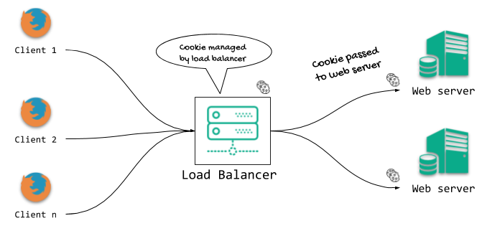

Handling cookies using Load Balancer

There are **multiple ways to address this issue**:

1. **Two servers always talk to each other**. **Whenever server 1 issues a cookie**, it also tells server 2 about this new cookie. **Server 2 would then store that in its memory**. Vice is versa is also applicable. When user logs out, similar thing happens. Cookie on other server is destroyed. This is known as **session trickling**.
2. First approach is rudimentary. Better approach to share cookie is via **shared Database** like MySQL. Concept is same. Only thing is, instead of communicating directly, servers co-ordinate via database.
3. Second approach is better but **slower** as every request would involve **database call**. To tackle this, high speed **in-memory databases like Redis** are used. Redis is **NoSQL**, Key-Value database which is perfect fit for this scenario.

Handling cookies using Redis like high speed in-memory database

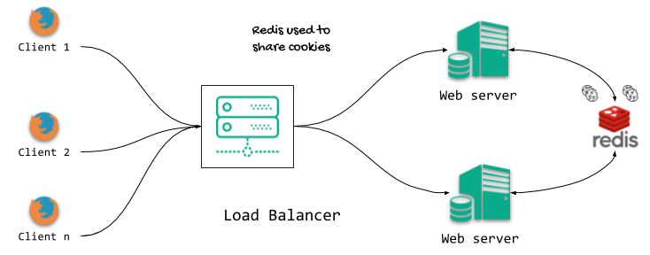

1. In a different scenario, where we have micro-services, our API servers or web servers are hidden behind a **firewall** and there is a separate service that is responsible for issuing and validating cookies. Sometimes application **gateways/load balancers are responsible for cookies** and web servers are hidden from direct access.
2. **HTTP remember-me feature in log in vs save password**

**Generally,**

The **"save password**" part comes from the **browser's password manager** whenever it sees an <input type="password"> that looks like it really is asking for a password. You can use the autocomplete attribute to suppress this in most browsers:

<input type="password" name="password" **autocomplete**="off">

This won't validate but that usually doesn't matter.

The "**remember me**" part is completely separate from the browser's password manager. The "remember me" flag is the **server's business** and all it does is fiddle with the expiry date on the cookie that it sends back. The server will always send a cookie back (unless they're not using cookies for tracking sessions but that's rare and wouldn't need a "remember me" anyway) with something inside it to identify the client user.

If you **check "remember me"** then you're telling the server that you want a **persistent session**. To achieve this, the server will include an **expiry date** with the cookie and that expiry date will be some time in the future. When the date arrives, the browser will expire and delete the cookie; without the cookie, the server won't know who you are anymore and you'll have to login again.

If you **don't check "remember me"** then you'll get a **session cookie**. **Session cookies don't have expiry dates** on them so automatically expire when the browser exits. Session cookies are useful for shared machines.

Executive summary:

* "Save password" is from the **browser's password manager**.
* "Remember me" is about the login cookie's expiry time.

The **session id is stored in the cookie**. **while the password, or the hash of it is not stored**. A session is created on the server side whenever you log in. If you logged in with "Remember Me" checked**, the server passes a cookie with the session id (or encrypted session id, or something that uniquely identifies the user session) and this cookie is saved on the client side**.  
When you login for the next time, the **server checks whether there is a cookie with the session**, that means, server needs to save session ID in either database or memory for as long as expiry. if it is there (and the session has not been killed/expired - see point 2 below) then the server identifies you as "Veera" and lets you in the site.

# How "Remember me" works in Duo multi-factor authentication

The Remember me feature of Duo Mobile works for most people most of the time. However, it is not 100% reliable because the feature relies on web cookies of a particular type, and the web browser you are using must accept this type of cookie. These are common situations in which you may need to authenticate with Duo MFA each time you log in.

### Web browser issues

* Allowing cookies  
  Most web browsers have security and privacy settings that allow you to accept or reject cookies entirely. You must allow cookies to be set by *.northwestern.edu and *.duosecurity.com.
* Tracking or 3rd party cookies  
  **Cookies are often sent back only to the site that initially gave you the cookie**. But many web sites also use what are called *3rd party* cookies. These are also known as *tracking* or ***cross-site* cookies**, because they allow one web site (e.g., www.cnn.com), to track your visits to another site (e.g., www.facebook.com). Duo's Remember me cookie, although it is not used for tracking or advertising purposes, is indistinguishable from these cookies. More and more browsers are not allowing these cookies by default, though most let you adjust these settings.
* **Multiple browsers**  
  If you authenticate with Duo MFA using one browser (e.g., Chrome), then later login via another browser (e.g., Firefox), you will be prompted to authenticate with Duo MFA again. **Web browsers do not share cookies with each other.**
* Clearing cache/cookies  
  If you delete Duo's Remember me cookie by manually clearing your browser's cookies/cache, you will have to authenticate with Duo MFA again the next time you log in. Some web browsers can also be configured to clear cookies and/or cache each time they are launched.
* Private or Incognito mode  
  Most browsers have a private or incognito mode. When you use this, **cookies are not saved**, website addresses aren’t cached, and several other features are modified. You will always have to authenticate with Duo MFA when using incognito/private mode.

# Secure Remember Me for Login using PHP Session and Cookies

Last modified on September 11th, 2020.

Login Script with ‘Remember Me’ feature will allow the user to preserve their logged in status. When the user checks the **Remember Me** option, then the logged in status is serialized in the [PHP session or cookies](https://phppot.com/php/session-vs-cookies/) like storages. While writing user login data in the session or cookie we need to be aware of the security breaches which might compromise the application’s authentication system. Plain passwords should not be stored in the user’s cookie, this will allow hacking the application.

This example will help you [to build a persistent](https://phppot.com/php/how-to-build-a-persistent-shopping-cart-in-php/) authentication system for your PHP web application. When the user attempts to log in with the application, **the entered login credentials are verified with the database**. If a match is found, the PHP session and the cookies are used to preserve user logged-in state before redirecting the user to the dashboard. On successful login, **the unique member id from the member database is stored in a session**. Then, the cookies are set to keep the login name and the password for a specified expiration period.  **Instead of storing the users’ plain password, random password and token are generated and stored in the cookie to avoid hacking**.

When the user accessing the application pages, the [existing logged in session](https://phppot.com/php/php-login-script-with-session/) is checked to redirect the user to access the requested page. **If the session is empty, then the code will check the logged-in with the cookies**. If both the session and the cookies are not having any data about the remembered login, then the user will be redirected back to the login page. The authentication cookies are set with the expiration time of 1 month. The random password and tokens will be stored in the database with the expiration date and time. **The cookie-based logged in state validation is done by testing cookie availability and expiration stored in the database**.

1. **Cookie-based Authentication**

**What is in the cookie, format of auth. Cookie.**

## Examples of cookies

Cookies are most commonly used to track website activity. When you visit some sites, the server gives you a cookie that acts as your identification card. Upon each return visit to that site, your browser passes that cookie back to the server. In this way, a web server can gather information about which web pages are used the most, and which pages are gathering the most repeat hits.

Cookies are also used for online shopping. Online stores often use cookies that record any personal information you enter, as well as any items in your electronic shopping cart, so that you don't need to re-enter this information each time you visit the site.

Servers can use cookies to provide personalized web pages. When you select preferences at a site that uses this option, the server places the information in a cookie. When you return, the server uses the information in the cookie to create a customized page for you.

## Cookies are scoped by path: the Path attribute

Consider this backend which sets a new cookie for its frontend when visiting <http://127.0.0.1:5000/>. On the other two routes instead we print the request's cookies:

from flask import Flask, make_response, request

app = Flask(__name__)

@app.route("/", methods=["GET"])

def index():

response = make_response("Here, take some cookie!")

response.set_cookie(key="id", value="3db4adj3d", path="/about/")

return response

@app.route("/about/", methods=["GET"])

def about():

print(request.cookies)

return "Hello world!"

@app.route("/contact/", methods=["GET"])

def contact():

print(request.cookies)

return "Hello world!"

To run the app:

FLASK_ENV=development FLASK_APP=flask_app.py flask run

In another terminal, if we make connection with the root route we can see the cookie in Set-Cookie:

curl -I http://127.0.0.1:5000/ --cookie-jar cookies

HTTP/1.0 200 OK

Content-Type: text/html; charset=utf-8

Content-Length: 23

Set-Cookie: id=3db4adj3d; Path=/about/

Server: Werkzeug/1.0.1 Python/3.8.3

Date: Wed, 27 May 2020 09:21:37 GMT

Notice how the cookies has a Path attribute:

Set-Cookie: id=3db4adj3d; Path=/about/

Let's now visit the /about/ route by sending the cookie we saved in the first visit:

curl -I http://127.0.0.1:5000/about/ --cookie cookies

In the terminal where the Flask app is running you should see:

ImmutableMultiDict([('id', '3db4adj3d')])

127.0.0.1 - - [27/May/2020 11:27:55] "HEAD /about/ HTTP/1.1" 200 -

As expected the cookie goes back to the backend. Now try to visit the /contact/ route:

curl -I http://127.0.0.1:5000/contact/ --cookie cookies

This time in the terminal where the Flask app is running you should see:

ImmutableMultiDict([])

127.0.0.1 - - [27/May/2020 11:29:00] "HEAD /contact/ HTTP/1.1" 200 -

What that means? Cookies are scoped by path. **A cookie with a given** Path **attribute cannot be sent to another, unrelated path, even if both path live on the same domain**.

This is the first layer of **permissions** for cookies.

When Path is omitted during cookie creation, the browsers defaults to **/**.

## Cookies are scoped by domain: the Domain attribute

The value for the Domain attribute of a cookie controls **whether the browser should accept it or not** and **where the cookie goes back**.

Let's see some examples.

**NOTE**: the following URL are on free Heroku instances. Give it a second to spin up. Open up a browser's console before opening the links to see the result in the network tab.

### Non matching host (wrong host)

Consider the following cookie set by <https://serene-bastion-01422.herokuapp.com/get-wrong-domain-cookie/>:

Set-Cookie: coookiename=wr0ng-d0m41n-c00k13; Domain=api.valentinog.com

Here the cookie originates from **serene-bastion-01422.herokuapp.com**, but the Domain attribute has **api.valentinog.com**.

There's no other choice for the browser to **reject this cookie**. Chrome for example gives a warning (Firefox does not):

[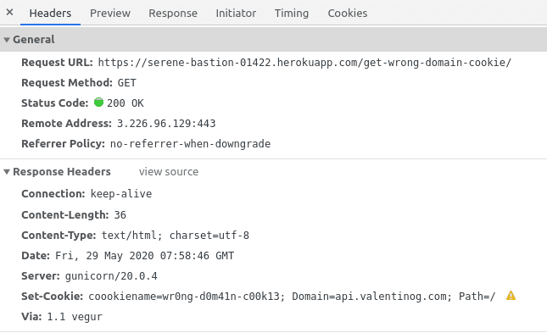](https://www.valentinog.com/blog/static/0f0923a1ac35891f603506fa6ebb5a2f/af192/chrome-reject-wrong-domain-cookie.png)

### Non matching host (subdomain)

Consider the following cookie set by <https://serene-bastion-01422.herokuapp.com/get-wrong-subdomain-cookie/>:

Set-Cookie: coookiename=wr0ng-subd0m41n-c00k13; Domain=secure-brushlands-44802.herokuapp.com

Here the cookie originates from **serene-bastion-01422.herokuapp.com**, but the Domain attribute is **secure-brushlands-44802.herokuapp.com**.

They are on the same domain, but the subdomain is different. Again, the browser rejects this cookie as well:

[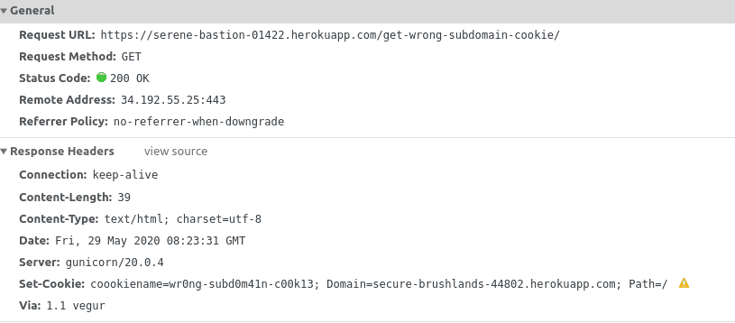](https://www.valentinog.com/blog/static/e0417b91d463c255f06fbbc9a39f47b7/ef916/chrome-reject-wrong-subdomain-cookie.png)

### Matching host (whole domain)

Consider now the following cookie set by visiting <https://www.valentinog.com/get-domain-cookie.html>:

set-cookie: cookiename=d0m41n-c00k13; Domain=valentinog.com

This cookie is set at the web server level with [Nginx add_header](http://nginx.org/en/docs/http/ngx_http_headers_module.html):

add_header Set-Cookie "cookiename=d0m41n-c00k13; Domain=valentinog.com";

I **used Nginx here to show you there are various ways to set a cookie**. The fact that a cookie is set by a web server or by the application's code **doesn't matter much for the browser**.

What matters is the domain the cookie is coming from.

Here the browser will **happily accept the cookie** because the host in Domain **includes the host from which the cookie came**.

In other words, **valentinog.com** includes the **subdomain www.valentinog.com**.

Also, the **cookie travels back with any new request against valentinog.com**, as well as **any request to subdomains on valentinog.com**.

Here's a request to the www subdomain with the cookie attached:

Here's a request to the **subdomain:** www with the cookie attached:

[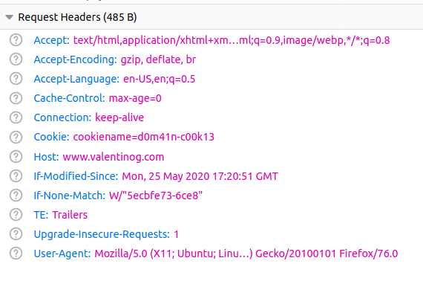](https://www.valentinog.com/blog/static/04ed9576c4bdf1207e531eaa6c76618e/432e7/cookie-sent-back-domain-matches.png)

Here's a request to another **subdomain**: **api** with the cookie automatically attached:

[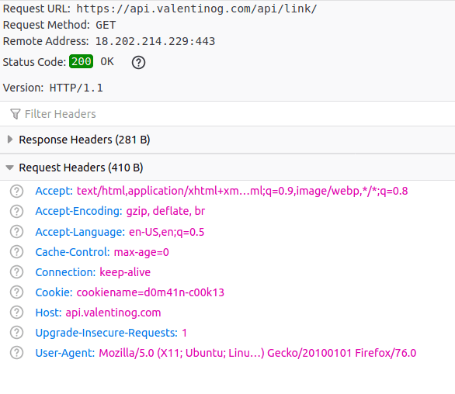](https://www.valentinog.com/blog/static/759672f4eb6e4517cf8dc091521f889d/a76f4/cookie-subdomain-sent-back-domain-matches.png)

### Cookies and the Public Suffix List

Now consider the following cookie set by <https://serene-bastion-01422.herokuapp.com/get-domain-cookie/>:

Set-Cookie: coookiename=d0m41n-c00k13; Domain=herokuapp.com

Here the cookie comes from **serene-bastion-01422.herokuapp.com**, and the Domain attribute is **herokuapp.com**. What should the browser do here?

You **might think that serene-bastion-01422.herokuapp.com is included in the domain herokuapp.com**, so the browser should accept the cookie.

Instead, **it rejects the cookie** because it comes from a domain included in the **Public Suffix List**.

The **Public Suffix List** is a list maintained by Mozilla, used by all browsers to restrict who can set cookies on behalf of other domains.

Resources:

* [Public suffix list](https://publicsuffix.org/)
* [Cookies and the Public Suffix List](https://devcenter.heroku.com/articles/cookies-and-herokuapp-com)

### **Matching host (subdomain)**

Consider now the following cookie set by <https://serene-bastion-01422.herokuapp.com/get-subdomain-cookie/>:

Set-Cookie: coookiename=subd0m41n-c00k13

When Domain**is omitted during cookie creation**, the browsers defaults to the originating host in the address bar, in this case my code does:

response.set_cookie(key="coookiename", value="subd0m41n-c00k13")

When the cookie lands in the browser's cookie storage we see the Domain applied:

[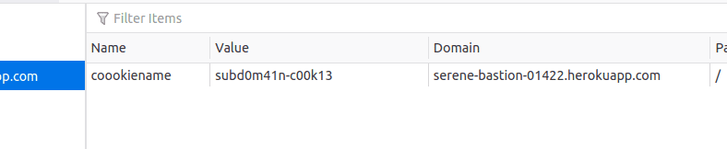](https://www.valentinog.com/blog/static/7545527e090e86cf1793a5cef2daeae9/ea7fb/default-domain-cookie.png)

So we have this cookie from serene-bastion-01422.herokuapp.com. **Where this cookie should be sent now?**.

If you visit <https://serene-bastion-01422.herokuapp.com/> the cookie goes with the request:

[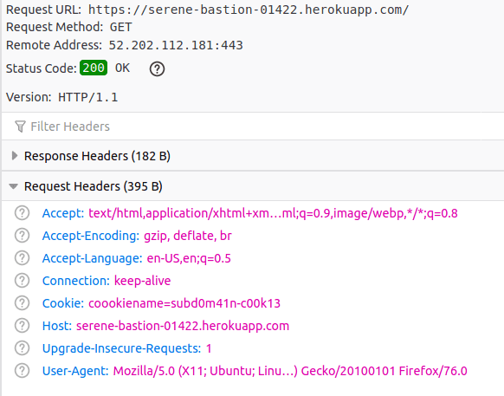](https://www.valentinog.com/blog/static/12375a46d81a8f8384786c7ac302d393/7c1cd/cookie-sent-subdomain.png)

**But, if you visit herokuapp.com**, **the cookie does not leave the browser at all**:

[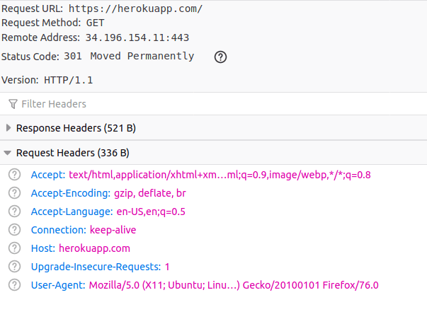](https://www.valentinog.com/blog/static/d9cb09c285639425f6d5a8e2434c5b40/9128f/cookie-subdomain-to-domain-not-sent.png)

(It doesn't matter that herokuapp.com later redirects to heroku.com).

To recap, **the browser uses the following heuristics to decide what to do with cookies** (by sender host here I mean the actual URL you visit):

* **Reject the cookie** altogether if either the domain or the subdomain in Domain don't match the sender host
* **Reject the cookie** if the value of Domain is included in the Public suffix list
* **Accept the cookie** if the domain or the subdomain in Domain matches the sender host

Once the browsers accepts the cookie, and it's about to **make a request** it says:

* **Send it back the cookie** if the request host matches exactly the value I saw in Domain
* **Send it back the cookie** if the request host is a subdomain matching exactly the value I saw in Domain
* **Send it back the cookie** if the request host is a subdomain like sub.example.dev included in a Domain like example.dev
* **Don't send it back the cookie** if the request host is a main domain like example.dev and Domain was sub.example.dev

**Takeaway**: Domain is the second layer of **permissions** for cookies, alongside with the Path attribute.

## Cookies and authentication

Authentication is one of the most challenging tasks in web development. There seems to be so much confusion around this topic, as **token based authentication with JWT** seems to supersede "old", solid patterns like **session based authentication**.

Let's see what role cookies play here.

### **Session based authentication**

**Authentication** is one of the most common use case for cookies.

When you visit a website that requests authentication, **on credential submit** (through a form for example) the backend sends under the hood a Set-Cookie header to the frontend.

A typical **session cookie** looks like the following:

Set-Cookie: **sessionid**=sty1z3kz11mpqxjv648mqwlx4ginpt6c; **expires**=Tue, 09 Jun 2020 15:46:52 GMT; HttpOnly; Max-Age=1209600; Path=/; SameSite=Lax

In this Set-Cookie header the server may include a cookie named **session, session id, or similar**.

This is the only identifier that the browser can see in the clear. Any time the **authenticated user requests a new page to the backend, the browser sends back the session cookie**.

**At this point the backend pairs the session id with the session stored on a storage behind the scenes to properly identify the user.**

Session based authentication is known as **stateful** because the backend has to keep track of sessions for each user. The storage for these sessions might be:

* a database
* a key/value store like Redis
* the filesystem

Of these three session storages, Redis or the like should be preferred over database or filesystem.

Note that session based authentication has **nothing to do with the browser's Session Storage**.

It's called **session based** only because the relevant data for user identification lives in the **backend's session storage**, which is not the same thing as a browser's Session Storage.

### When to use session based authentication?

Use it **whenever you can**. **Session based authentication is one of the simplest, secure, and straightforward form of authentication for websites**. It's available by default on all the most popular web frameworks like Django.

But, its **stateful** nature is also its main drawback, especially when a website is served by a **load balancer**. In this case, techniques like **sticky sessions**, or **storing sessions on a centralized Redis storage** can help.

1. **Cookie Domain and Path**

Back in the days of the good old web 1.0 cookies were implemented to preserve and persist state information on the side of the User Agent (mostly a web browser). The nitty gritty details are all written down in [RFC 6265](https://tools.ietf.org/html/rfc6265/), but it all boils down to cookies being key-value pairs that can be written to the User Agent using the Set-Cookie http header in the response. Besides the cookie name (the key) and its value, other options can additionally be set to control when a cookie should expire (expires or the newer max-age), if it may be sent via http or only via https (**Secure**), and **if JavaScript in the browser should be able to read and write the cookie value** or if the cookie should **be hidden from JavaScript** and only be sent to the server (**HttpOnly**).

If a cookie is set and not yet expired, the User Agent sends the cookie along to the server with **every request that matches the domain and path values** that can also be set on a cookie. What do they do?

Let's assume there is a website on www.example.com and it allows you to log in to customize your experience. Your log in session is stored in a session cookie. The website also offers a store at shop.example.com which uses the same login mechanism. With the default behavior, the cookie would be set to www.example.com and not be sent to shop.example.com, so you would have to log in at both subdomains explicitly. When the website sets the cookie using the **domain=example.com** parameter, the cookie will be sent to all **subdomains of example.com**, and so the user only needs to **login once**. You can only use the domain option to **narrow or broaden** the scope of the cookie on your own domain: The value set of the domain option must be part of the host name that is sending the Set-Cookie header. So you can't set a cookie for thinktecture.com as that would introduce a security issue.

The path allows you to further **narrow down** the places where a cookie will be sent to. If, for example, the website sets the cookie and states domain=example.com; path=/blog, then the cookie will only be sent to the server **if the request starts with /blog**, so it would be sent to www.example.com/blog and shop.example.com/blogroll, but not to example.com/blo.

* Cookies can only be set for the current domain or its subdomains as you have already found out (otherwise, anyone could replace anyone else's cookie; chaos would ensue). **This is enforced by the browser**: if you attempt to set cookies for another domain from the server side (using an HTTP header) the browser will ignore the cookie. **If you attempt to do the same from the client side (using Javascript)**, the [same origin policy](http://en.wikipedia.org/wiki/Same_origin_policy) will prevent you from doing so.
* Therefore, www.evilsite.com can set a cookie for its own domain with Javascript, but that's not an issue: it could already do that using an HTTP header. There's no new attack vector here.
* Cookie Domain Match
* Cookie with Domain=.example.com **will** be available for *www.example.com*
* Cookie with Domain=.example.com **will** be available for *example.com*
* Cookie with Domain=**example.com** will be converted to **.example.com** and thus **will** also be available for *www.example.com*
* Cookie with Domain=example.com will **not** be available for *anotherexample.com*
* *www.example.com* **will** be able to set cookie for *example.com*
* *www.example.com* will **not** be able to set cookie for *www2.example.com*
* *www.example.com* will **not** be able to set cookie for *.com*

.www.example.com will only be accessible for other domains below that domain (e.g. **foo.**www.example.com or **bar.**www.example.com)

**.**example.com can also be accessed by any other domain below example.com (e.g. foo.example.com or bar.example.com, and example.com)

1. [**How client know which cookies should be send to the server**](https://stackoverflow.com/questions/49707593/how-client-know-which-cookies-should-be-send-to-the-server)

* Each domain has its own cookies in a cookie jar / cookie store. Whenever a request is made by the browser to the server, **all cookies in the store for that domain or subdomain** will be **sent to the server**.
* The cookies are saved in the browser, the **browser** maintains a **cookie file somewhere for each domain**. Once a request to that domain is made the entire content of the cookie file is sent as cookies to the server. **These cookies may have been generated** by the server or by a **javascript call**. The cookies are not necessarily created by the previous response from the server.

To directly answer the question: the client sends back **all** cookie data it has for that **domain** and **path**.

If you do not see any Set-Cookie header in any HTTP response, it may be because the cookie has been issued by server and stored on your computer **before you started looking** at Dev Tools or Fiddler. It could have been up to a few days, weeks, even months ago.

In Firefox, if you navigate to about:preferences#privacy and click Manage Data, you can see which domains already have cookies issued and stored on your computer. The Storage tab in Firefox Dev Tools can show you details of all cookies. The expiry of the cookie is determined by the server, using the Expires or Max-Age directive in the Set-Cookie header.

**How a cookie first ended up on the client computer:**

1. Client makes its first ever HTTP request to server, e.g. GET www.example.com
2. Server creates a cookie and sends it back in the HTTP response, e.g. the response headers contains a line: Set-Cookie: sessionID=1234567; path=/; Max-Age=31536000
3. The client receives HTTP response and stores the cookie in the "jar" for domain [www.example.com](http://www.example.com).

**`**

In subsequent HTTP requests to domain www.example.com, the client sends back all cookies in the jar that matches the path or sub-path. For example, the client wishes to issue a request GET www.example.com/about, sees that the URL is a sub-path of / in domain www.example.com, so it sends the cookie as a line in the HTTP request header, i.e. Cookie: sessionID=1234567.

The server sees the cookie and knows exactly which client made this request.

* **secure cookies vs insecure cookies**
* Secure cookies will be sent only on connections that are made over SSL(https protocol). Normal cookies will be sent on both http and https protocols.
* **session cookies vs. persistent cookies**
* session cookies - These cookies persist as long as the browser session is open. This means that Once you have cleared cache or closed the browser they get lost.
* persistent cookies - These will persist even if the browser is closed and opened again unless you have set the browser to clear cookies on exit in which case they will behave just like session cookies.
* **First party cookies vs. Third party cookies**.
* First party cookies - generated by the domain currently open as main document - this means they have same domain as the one displayed in your browser.
* Third party cookies - generated by a different domain thnn currently opened by the browser(in the addressbar) but which are **managed inside an iframe or various resource calls** like css, **script**, media(images, videos or other embedded media)

**Cookie Domain**

## Understanding Cookie Domain and sub-domain

As discussed earlier, cookies have a Domain directive which indicates one or more domains for which the cookie should be sent. **By default, domain is set to the host name of the page setting the cookie**.

Imagine a website [https://google.com](https://google.com/) setting a following header:

Set-Cookie: id=1234;

So, browser will send the cookie with every subsequent request to [https://google.com](https://google.com/) domain. Since, **default value of the domain is used, browser will not send this cookie to any sub-domain of google.com.** Thus cookie will not be sent by browser for requests to following domains:

* [https://mail.google.com](https://mail.google.com/)
* [https://drive.google.com](https://drive.google.com/)
* [https://files.drive.google.com](https://files.drive.google.com/)

However if [https://google.com](https://google.com/) sends following header:

Set-Cookie: id=1234; **Domain=google.com**

Since, server has explicitly specified domain value, browser would send cookie for any sub-domain of [https://*.google.com](https://blog.webf.zone/*.google.com). As explained by [Nicolas Zakas](https://www.nczonline.net/blog/2009/05/05/http-cookies-explained/), **browser performs a tail comparison of this value and the host name to which a request is sent** (meaning it starts the comparison from the end of the string) and sends the corresponding Cookie header when there’s a match. We can also conclude that —

Parent domain can set cookies for Sub-domain and Sub-domain can also set cookies for Parent domain.

The 2 domains mydomain.com and subdomain.mydomain.com can only share cookies if the domain is explicitly named in the Set-Cookie header. Otherwise, the scope of the cookie is restricted to the request host. (This is referred to as a "host-only cookie". See [What is a host only cookie?](https://stackoverflow.com/questions/12387338/what-is-a-host-only-cookie))

For instance, if you sent the following header from subdomain.mydomain.com, then the cookie won't be sent for requests to mydomain.com:

Set-Cookie: name=value

However if you use the following, it will be usable on both domains:

Set-Cookie: name=value; domain=mydomain.com

This cookie will be sent for any subdomain of mydomain.com, including nested subdomains like subsub.subdomain.mydomain.com.

In [RFC 2109](http://tools.ietf.org/html/rfc2109), a domain without a leading dot meant that it could not be used on subdomains, and only a leading dot (.mydomain.com) would allow it to be used across multiple subdomains (but not the top-level domain, so what you ask was not possible in the older spec).

However, all modern browsers respect the newer specification [RFC 6265](http://tools.ietf.org/html/rfc6265), and will ignore any leading dot, meaning you can use the cookie on subdomains as well as the top-level domain.

In summary, if you set a cookie like the second example above from mydomain.com, it would be accessible by subdomain.mydomain.com, and vice versa. This can also be used to allow sub1.mydomain.com and sub2.mydomain.com to share cookies.

**CORS** - cross domain calls via xhttp ajax calls - this case arises when you create a domain requests resources from another domain via xhttp(ajax calls).

In this case the browser makes a preflight check to see if the receiving domain accepts queries from the origin domain(origin headers are sent to the domain to check the cross domain policy). The server must necessarily respond with a valid options header and the server may allow identity data which is short for cookie data. If the remote domain has answered correctly with an "Access-Control-Allow-Origin" header that allows your domain or "*" then you are allowed to send cookies via this request. And these will behave just like normal calls.

## what data do Cookies collect

The most common attributes include:

* A randomly generated and unique number that is used to recognize your computer. This makes web applications such as online shops and online banking possible: The website "remembers" you accordingly, so that, for example, the previously selected goods do not disappear from your shopping basket every time you call up a new page.
* The [domain name](https://www.ionos.com/digitalguide/domains/domain-tips/what-is-a-domain/), i.e. the website to which the cookie refers. A website visit can also generate several cookies if, for example, image files are hosted on another server.
* **User settings**such as language and special preferences. The website operator does not want to force the user to adjust the website according to their needs each time they visit it. Therefore, such settings are stored by cookies.
* **Time spent**on the website or individual sub-pages. This data is collected for statistical evaluation.
* **Data entered by the user via web forms –**such as e-mail address, name, or telephone number. This also includes search terms entered in search masks.
* **Visited sub-pages** such as product pages in online shops. This data is highly relevant for online marketing.
* **Meta data** such as the expiry date or time of a cookie, the path, and the security specifications (e.g. “HTTPS only”). While some cookies are deleted after leaving the website (which is particularly common in online banking), other cookies remain for years.

1. **Cookie Security**

Imagine that after login, our web server at **www.example.com** sets a session cookie like this:

Set-Cookie: **session=89bea4bb-85d1-4f8b-b4fa-a9b8db015e2b**; Max-Age=2600000; **Domain=example.com**; **Path=/**; Secure; HttpOnly.

Whenever the browser sends a request using https, our server can nosh the fine cookie and from its taste it knows that there's a session with the GUID 89bea4bb-85d1-4f8b-b4fa-a9b8db015e2b.It can then answer the request and amend it with information from the user that is currently logged in with this session id. The web shop at **shop.example.com** is a single-page web application and it communicates with **api.example.com**, which also uses the same session cookie information

**An attacker** now sets up a new websites. Let's call it example-com-product-reviews.**attacker.com**. The attacker lures users onto his website by providing additional information for products only found on shop.example.com. **When a user visits his site**, he returns a website with some content and **additional JavaScript**. The JavaScript can't read our session cookie. **First of all**, example-com-product-reviews.attacker.com is not matched by the example.com domain option, and **secondly** the cookie is set to **HttpOnly**, so JavaScript can't touch it anyways. This way the **attacking JavaScript** can't do anything with our cookie directly. But **what the JavaScript can do is use the Fetch API (the modern replacement of the old XMLHttpRequest object) to send a request to the shops API**. It could, for example send a malicious request to POST https://api.example.com/addItemToCart?itemId=123.

While the user reads the information presented on example-com-product-reviews.attacker.com, the **JavaScript executes and the browser sends the request**. Since this **request** is sent to api.example.com, which matches the domain option from our session cookie, and the path also matches, **the browser indeed attaches the cookie** to the request. The API server receives the request, finds the attached session cookie, determines the user and adds a very expensive item to the shopping cart - without the user even noticing.

Another forged request like POST https://api.example.com/checkoutUsingAlreadyProvidedPaymentMethod could then cause real damage.

This attack method is known as **Cross Site Request Forgery**, or short CSRF. If you want you can read more about that in the [CRSF Page on OWASP](https://owasp.org/www-community/attacks/csrf).

Now, there is another technology in place that could help prevent these kinds of attacks. It is called CORS (**Cross Origin Resource Sharing**) and involves a bit of knowledge on how to apply it correctly. For now, we assume that somehow the common development setting Allow any origin made it on the production server on api.example.com instead of a specific setting to only allow requests from shop.example.com. And while this might sound a bit constructed, configuration mistakes can happen - and sadly they also do happen all the time. It just takes a project setup at a time where the final domains aren't known yet, so AnyOrigin is used for development purposes. Later when the shop needs to be rolled out everybody is so stressed out that nobody thinks about checking and reviewing all these // Todo: Configure this to the actual shop domain, OR ELSE! comments left in the codebase - in good faith that this will be done before release.

But what is the **'same' domain** as per the **SameSite** rules? Usually, the combination of second (**example**.com) and top level domain (example.**com**) is the common denominator. For example when the web application served from www.**example.com** sends a request to shop.**example.com**, this would be considered as a **same-site request**.

However, there are exceptions from that. One prominent example would be co.uk or co.jp, where commercial domain registrants get a **third level domain all under the co second level domain**. **uk and jp are third level domain**. Requests between mysite.co.uk and attacker.co.uk **should not be same-site**, although they are both under co.uk. **Another example** are subdomains that can be used by different parties, for example mysite.azurewebsites.net and attacker.azurewebsites.net for Microsoft Azure or *.compute.amazonaws.com for Amazons cloud services. Here you also want stronger isolation, as the sibling subdomains are absolutely not under your control.

Since the **browser needs to decide whether a request is same-site or not**, and technically anybody can register a domain and offer its subdomains for such purposes, there needs to be a way for browser vendors to figure out if a domain should be treated as same-site or not. This is where the [Public Suffix List](https://publicsuffix.org/) comes in handy. This list provides the domains that are a "public suffix" (aka under which different parties can register their own subdomains / prefixes).

Based on the information provided by this list, the Browsers are able to distinguish between first and third party cookies based on the current domain.

**Now, what do these SameSite Cookie options do?**

Let's go with the easiest settings first, **None**: This is the same as the original behavior of cookies where the SameSite option did not exist: Every cookie will be sent along with every request, as long as the values of domain and path match.

The second is **Strict**: This defines that cookies are only sent to the server when the request is *initiated* by a first-party context. What that actually means is that when you enter https://shop.example.com into your Browsers address bar, or you click on a link to that URL, **this very first request** to the server **is *not***yet a first-party context (as it was initiated by an unknown party**). Only subsequent requests that originate from that loaded page are considered being in the first-party context and as such provide the cookie to the server**.

Now, for our session cookie this is a bit too harsh: The first request to shop.example.com would not provide the session cookie, so the initial response of the shop would be the same as for a not-logged in user, but the next navigation on the application would show the user as logged in.

This is where **Lax** provides its services: This specifies that the cookie will be sent to the server also on top-level navigations to our site, i.e. when the user follows a link to our shop. **So even on the first navigation to our site the cookie will be sent and the user immediately appears as logged in**.

The most important thing is that Strict and Lax both will prevent sending of the cookies for all other requests from a 3rd party context. This means that in our example the web site served from example-com-product-reviews.attacker.com both described attacks won't work anymore. The image-tag requesting the user profile picture from our shop will not send the cookie along to shop.example.com (so the fake page won't be able to show the real users image). Nor will the browser send the cookie along with the POST requests to api.example.com.

## Cross-Site Scripting (XSS)

One of the most common usages of cookies is to store client data and an authenticated user session. If a hacker were to steal the cookie with this information, that client’s data or current user session could be exploited. XSS, or [Cross-Site Scripting](https://developer.mozilla.org/en-US/docs/Glossary/Cross-site_scripting), allows hackers to inject malicious client-side code in order to bypass controls and impersonate users. The browser itself cannot determine if the script is untrustworthy, so the hacker can access that client’s cookies, as well as tokens and site-specific information.

In order to mitigate these attacks, setting cookies with the HttpOnly flag prevents hackers from accessing a client’s cookies through Javascript. Additional security to prevent XSS can also be implemented with [Content Security Policies](https://developer.mozilla.org/en-US/docs/Web/HTTP/CSP).

## Cross-Site Request Forgery (CSRF)

A [Cross-Site Request Forgery](https://developer.mozilla.org/en-US/docs/Glossary/CSRF) is an attack that utilizes an authenticated user’s session and sends a site unwanted commands. It’s possible to create a CSRF by including malicious parameters in a URL that should go somewhere else. For example, if a client is logged into their bank account with valid cookies, it is possible that another tab or browser window (really, another site) has loaded an “image” with a URL request to withdraw money from your account and transfer it elsewhere. When the HTML on that other site loads, it will trigger the transfer immediately without preventative measures.

To prevent these attacks, there are several avenues to consider when focused on cookies. The first is to set the **SameSite** flag to either Strict or Lax for sensitive user actions to prevent untrustworthy cross-site requests. CSRF tokens (generated upon user sign-on) could also be implemented in hidden input fields for forms. The server can compare the received token against the expected token as another form of validation. By deploying both SameSite cookies and CSRF tokens, browsers can better protect against CSRF attacks — even those originating from a different subdomain.

#

Is it correct that session based authentication is the same as cookie-based authentication?

These phrases are not the same: "cookie based" reflects how session information gets transmitted while "session based" reflects that a session is used instead of having to login for every transaction again. "Session based" might be implemented with cookies and it typically is, but this is not an actual requirement. One could transmit the session for example in the URL too.

**Does session/cookie based authentication store user/session/... on server side**?

Not necessarily. All information can be stored inside the (signed/encrypted) cookie so that only the client actually stores the information and the server can extract the information from the cookie. Or the cookie can just be a key to look up the information in the servers database in which there is no need to sign/encrypt it.

# What is: Multifactor Authentication

When you sign into your online accounts - a process we call "authentication" - you're proving to the service that you are who you say you are. Traditionally that's been done with a username and a password. Unfortunately that's not a very good way to do it. Usernames are often easy to discover; sometimes they're just your email address. Since passwords can be hard to remember, people tend to pick simple ones, or use the same password at many different sites.

That's why almost all online services - banks, social media, shopping and yes, Microsoft 365 too - have added a way for your accounts to be more secure. You may hear it called "**Two-Step Verification**" or "**Multifactor Authentication**" but the good ones all operate off the same principle. When you sign into the account for the first time on a new device or application (like a web browser) you need more than just the username and password. You need a second thing - what we call a second "factor" - to prove who you are.

A factor in authentication is a way of confirming your identity when you try to sign in. For example, a password is one kind of factor, it's a thing you know. The three most common kinds of factors are:

* Something you know - Like a password, or a memorized PIN.
* Something you have - Like a smartphone, or a secure USB key.
* Something you are - Like a fingerprint, or facial recognition.

## How does multifactor authentication work?

Let's say you're going to sign into your work or school account, and you enter your username and password. If that's all you need then anybody who knows your username and password can sign in as you from anywhere in the world!

But if you have multifactor authentication enabled, things get more interesting. The first time you sign in on a device or app you enter your username and password as usual, then you get prompted to enter your second factor to verify your identity.

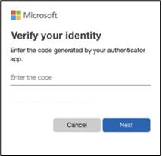

Perhaps you're using the free Microsoft Authenticator app as your second factor. You open the app on your smartphone, it shows you a dynamically created 6-digit number, which is unique to your phone, that you type into the site and you're in.

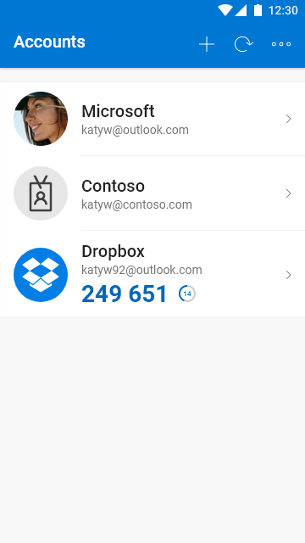

If somebody else tries to sign in as you, however, they'll enter your username and password, and when they get prompted for that second factor they're stuck! Unless they have YOUR smartphone they have no way of getting that 6-digit number to enter. And the 6-digit number in Microsoft Authenticator changes every 30 seconds, so even if they knew the number you used to sign in yesterday they're still locked out.

**Get the free Microsoft Authenticator app**

Microsoft Authenticator can be used not only for your Microsoft, work, or school accounts, you can also use it to secure your Facebook, Twitter, Google, Amazon, and many other kinds of accounts. It's free on iOS or Android. [Learn more and get it here](https://www.microsoft.com/en-us/account/authenticator).

## Important things to know

First, **it's important that the factors be different *kinds*of factors**. Having two passwords, or a password and a memorized PIN, is just two of the same kind of factor - things you know - and if somebody compromises one password, they could compromise both. It should be a combination of at least two of the three different kinds of factors to be secure. Crooks may steal your password, but they can't easily steal your fingerprint.

Second, **you won't have to do the second step every time you sign in**. Some people worry that multifactor authentication is going to be really inconvenient, but generally it's only used the first time you sign into an app or device, or the first time you sign in after changing your password. After that you'll just need your primary factor, usually a password, like you do now.

The extra security comes from the fact that somebody trying to break into your account is probably not doing so on your device so they'll need to have that second factor to get in.

**Multifactor authentication is not just for work or school**. Almost every online service from your bank, to your personal email, to your social media accounts supports adding a second step of authentication and you should go into the account settings for those services and turn that on.

* [Click here to turn two-step verification on for your personal Microsoft Account](http://go.microsoft.com/fwlink/?LinkId=529561)
* [Click here if you're an IT Pro or administrator and you want to know how to enable multifactor authentication for your Microsoft 365 account](https://docs.microsoft.com/en-us/microsoft-365/admin/security-and-compliance/set-up-multi-factor-authentication?view=o365-worldwide)

Compromised passwords are one of the most common ways that bad guys can get at your data, your identity, or your money. Using multifactor authentication, sometimes known as two-step verification, is one of the easiest ways to make it a lot harder for them.

# 6 Autofill Features for Web Developers

<https://betterprogramming.pub/6-autofill-features-for-web-developers-ac76b725b28a>

# Autofill

<https://web.dev/learn/forms/autofill/>

**How to verify 2-factor authentication using selenium Python**

**https://creativedata.stream/using-python-with-one-time-passwords-2fa/**

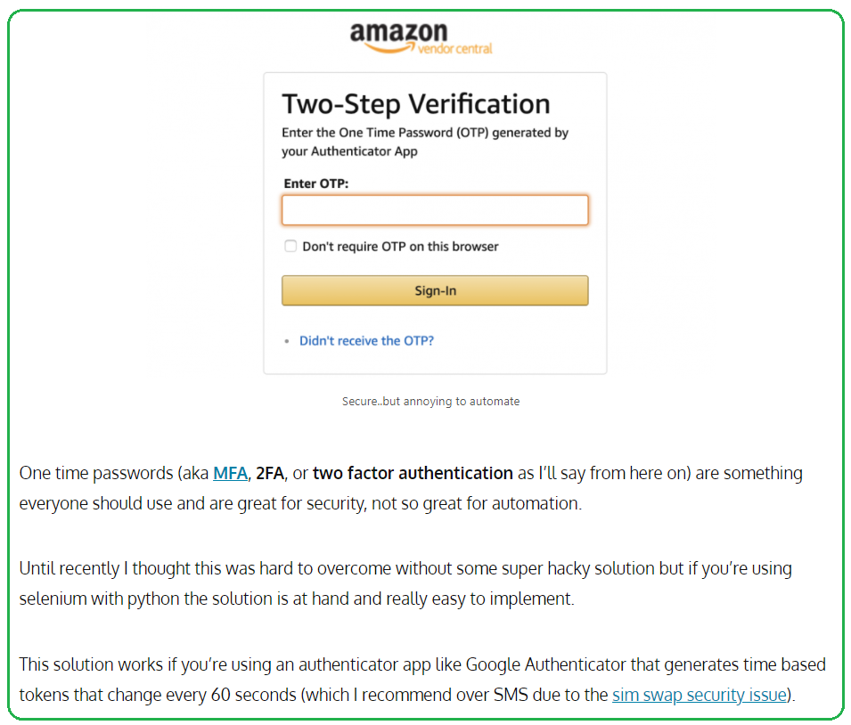

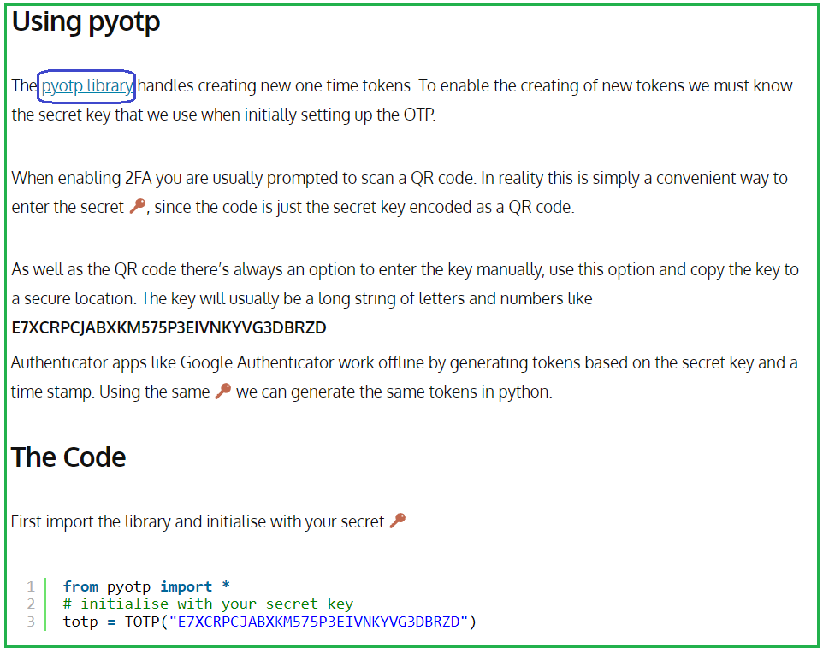

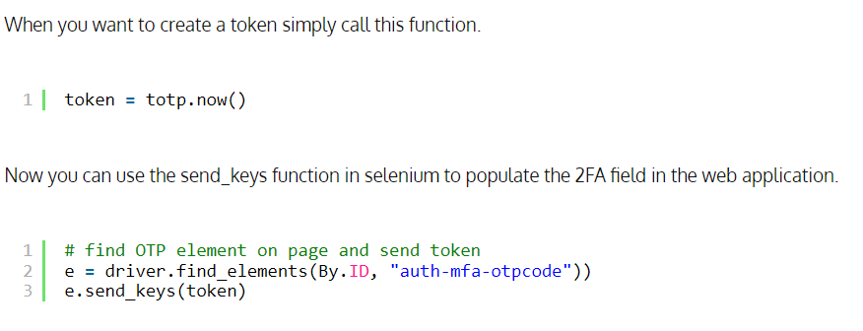

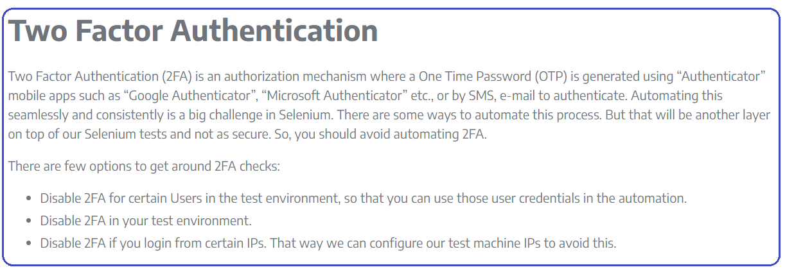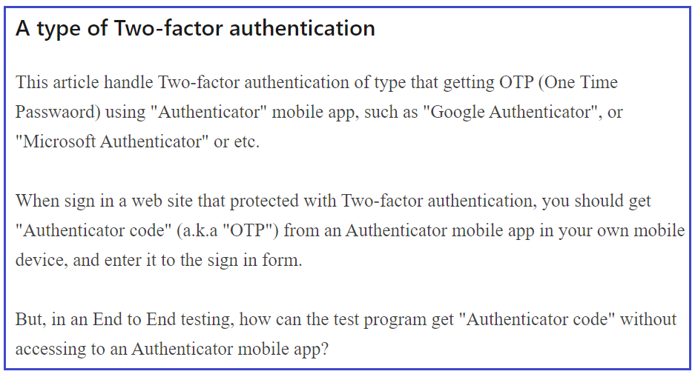

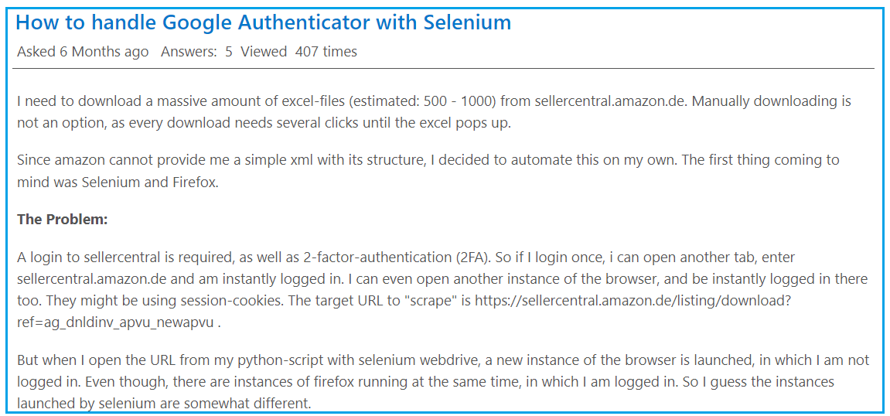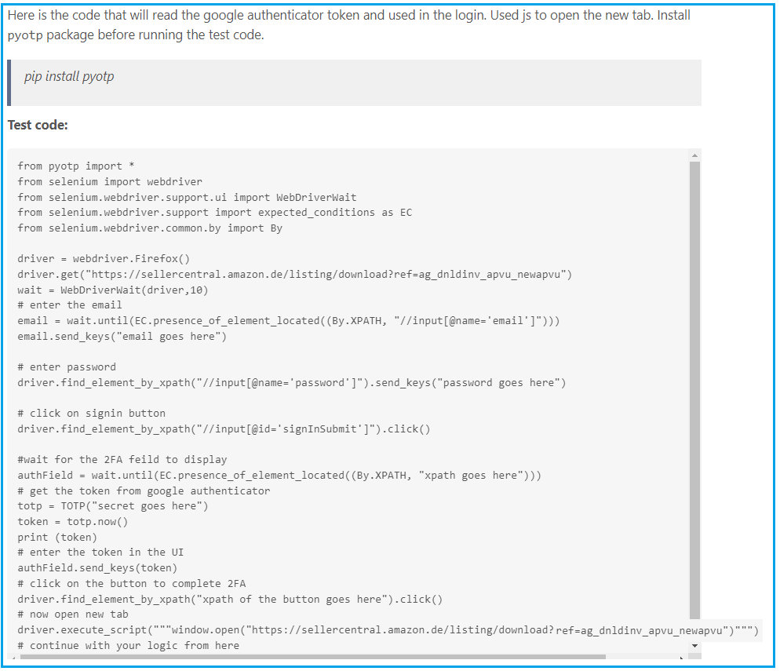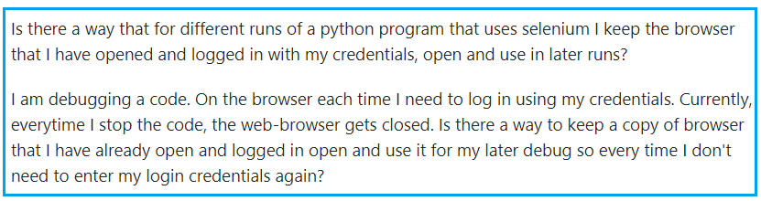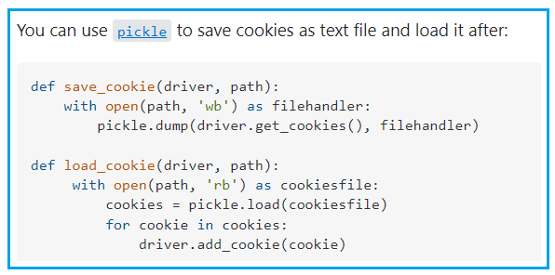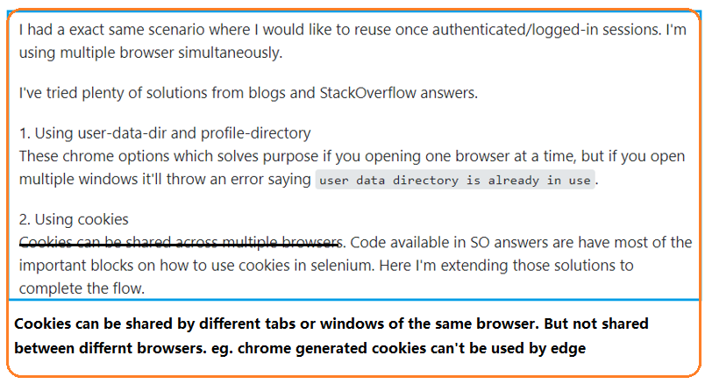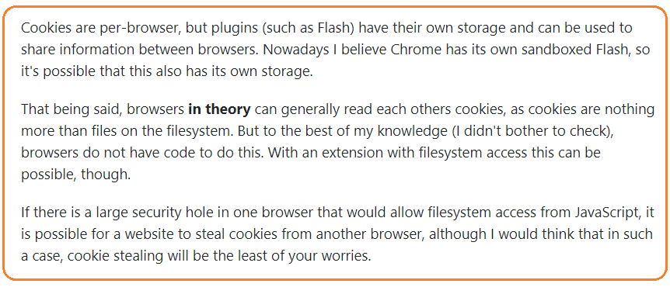

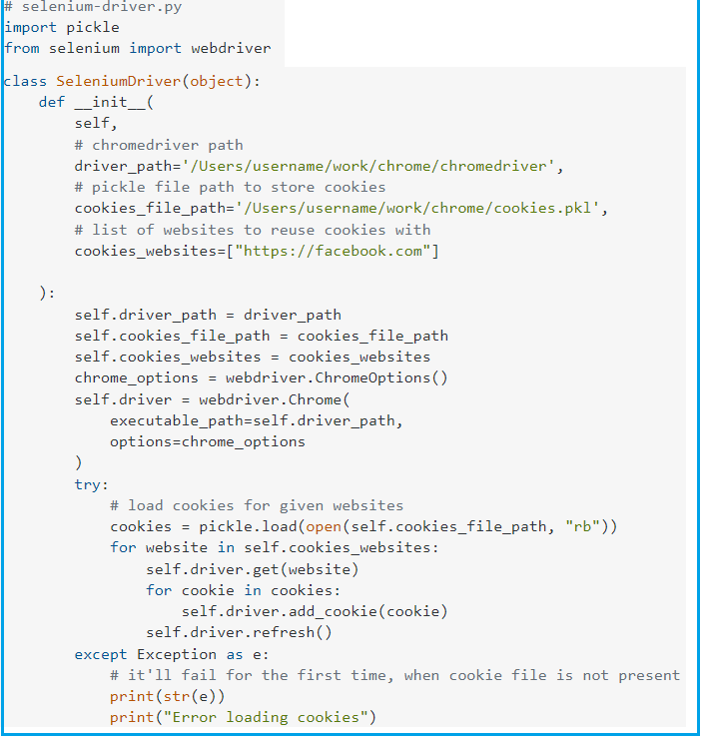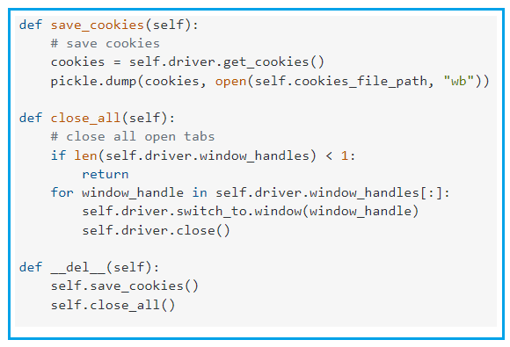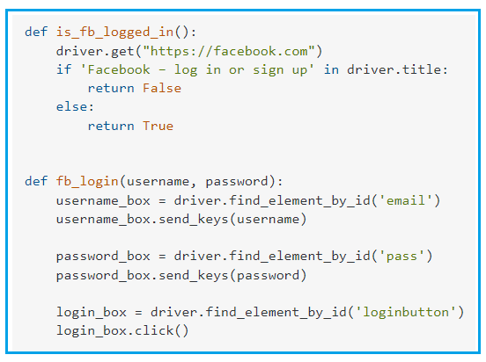

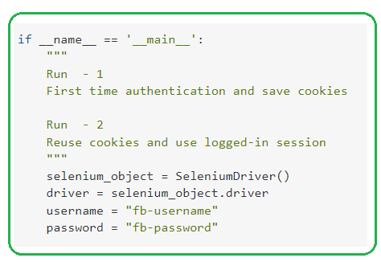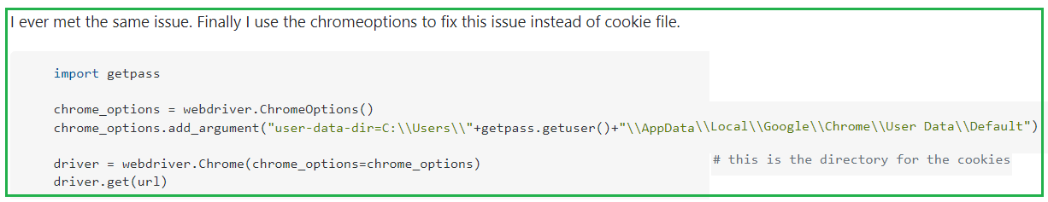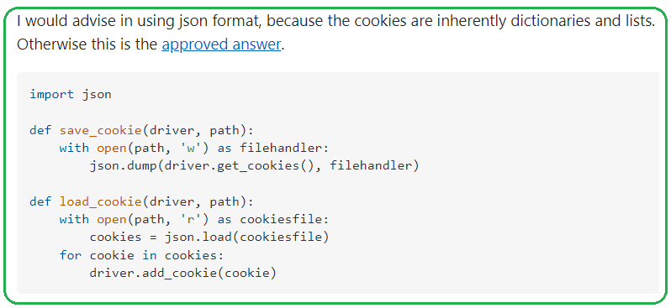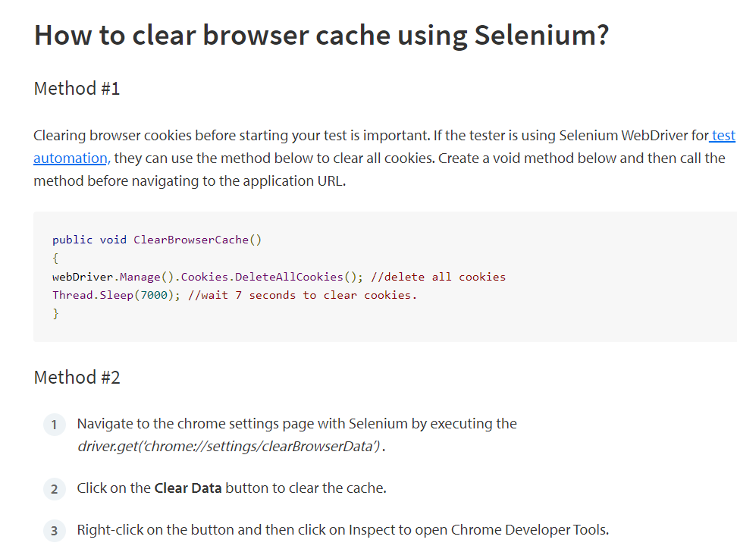

[Ask Question](https://stackoverflow.com/questions/ask)

<https://www.codestudyblog.com/cnb11/1124174146.html>

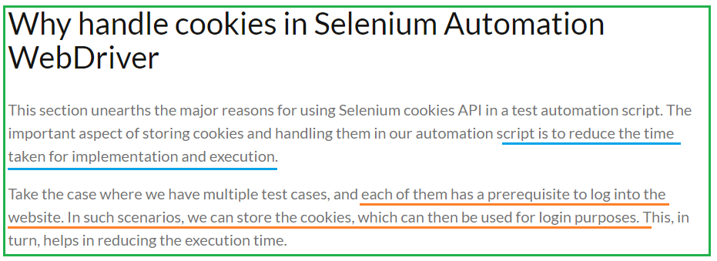

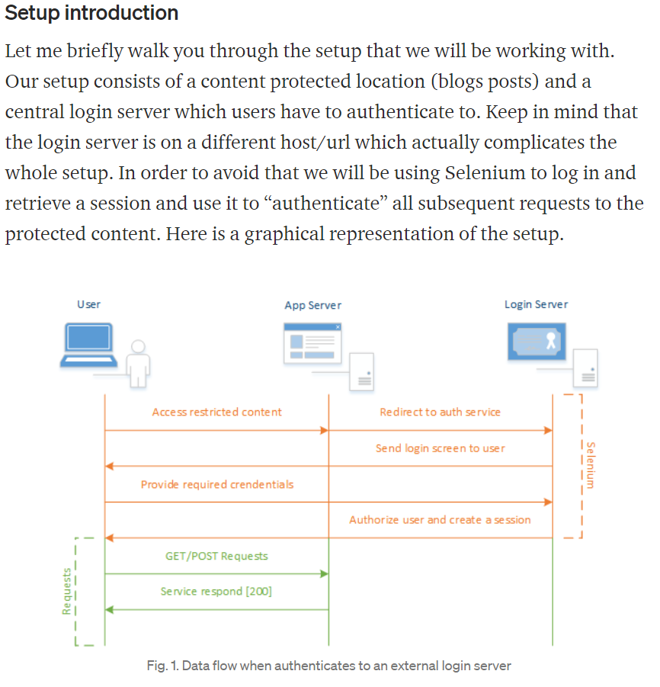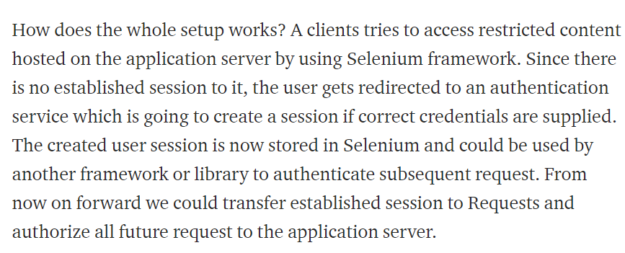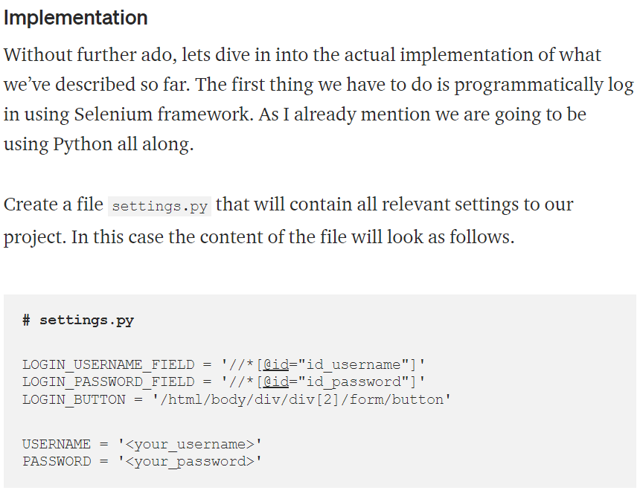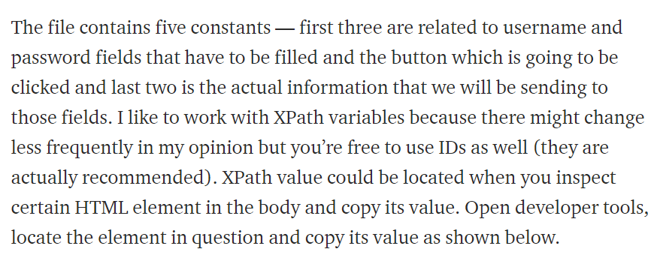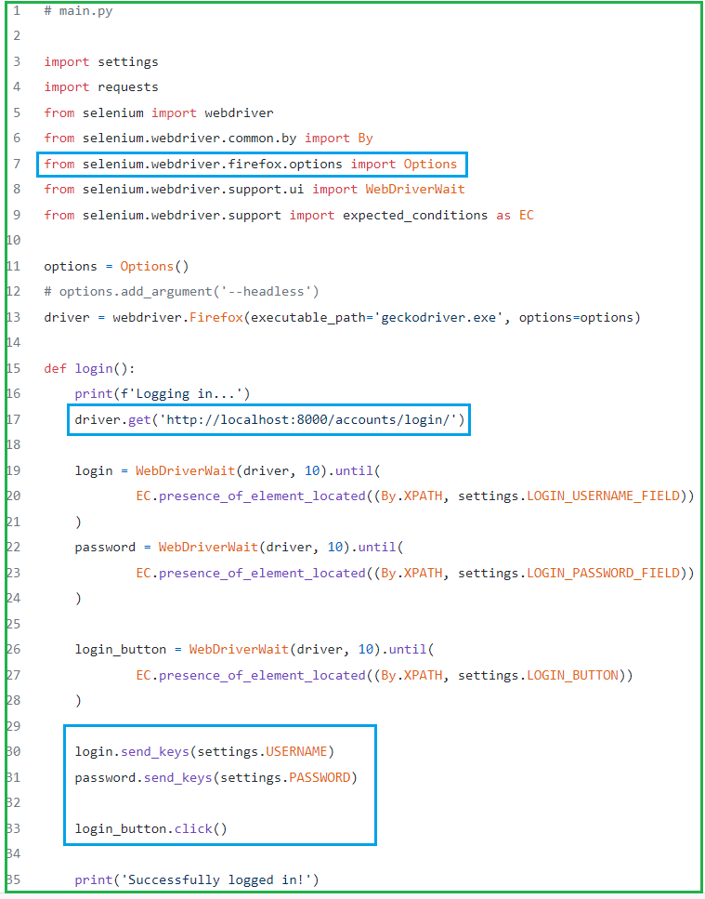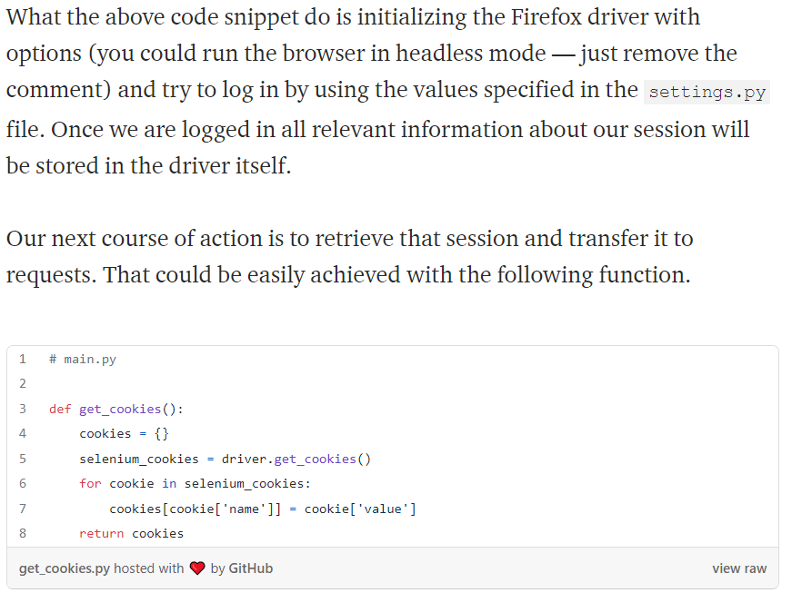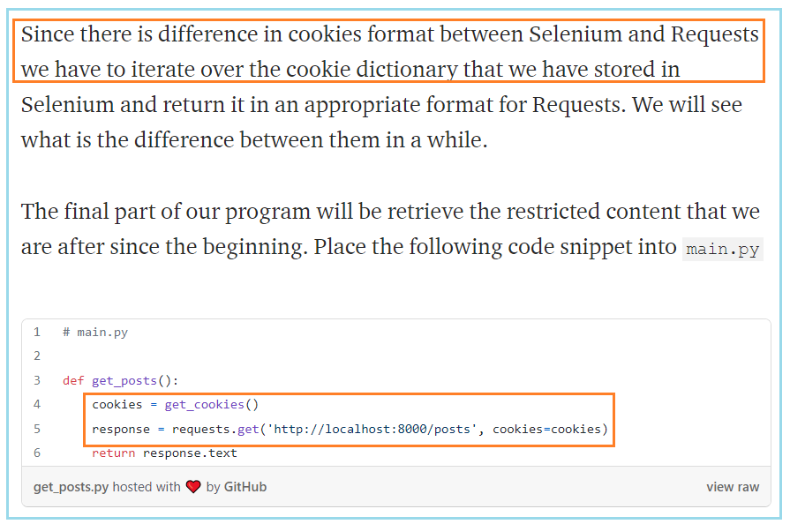

When you execute it, a new Firefox window should open with nothing on it and your prompt should look something like this.





Fig. 3. Python interactive mode

First we will try to get post’s page which have to result in a redirect to our login page

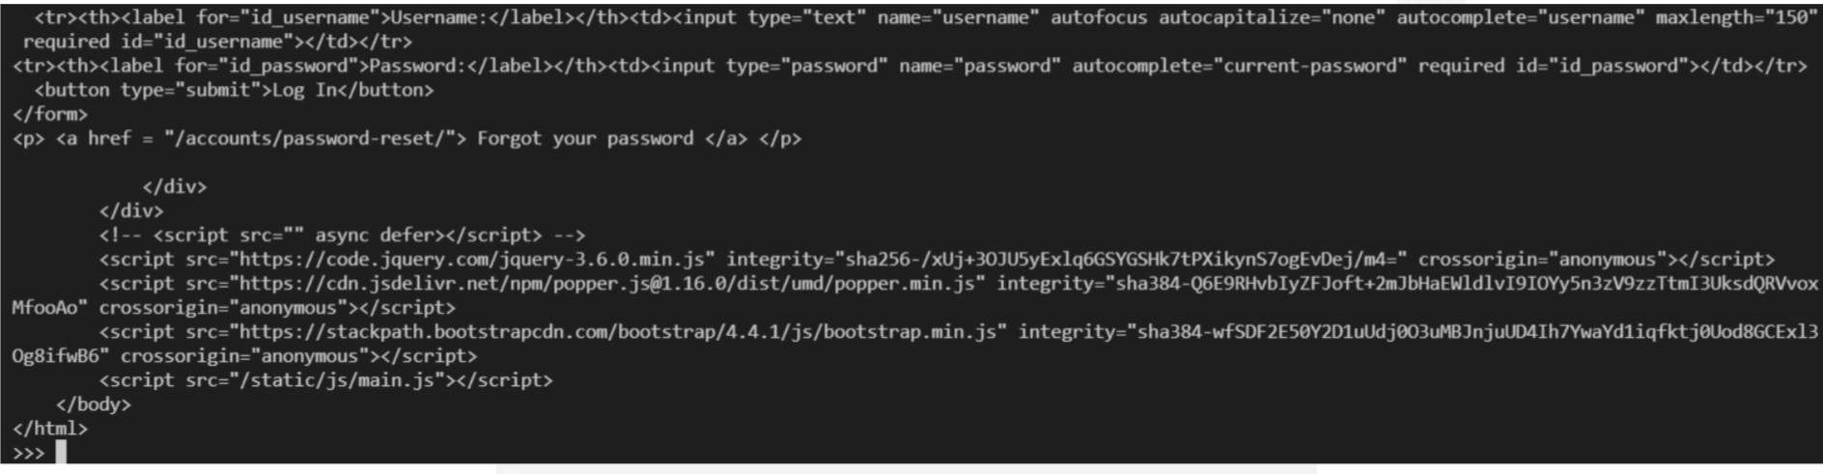

In deed we are being redirected to login page, which is something we want to avoid. Lets try to log in.

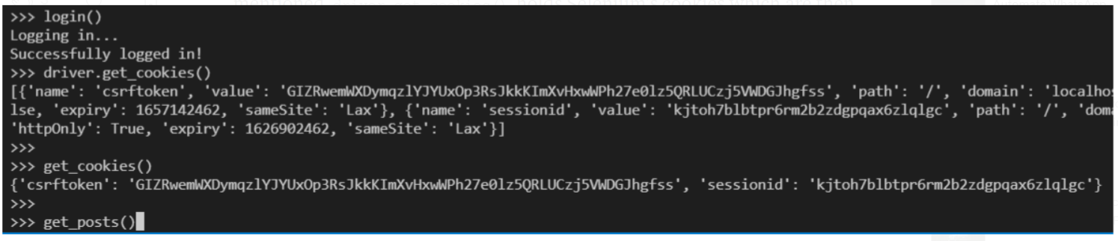

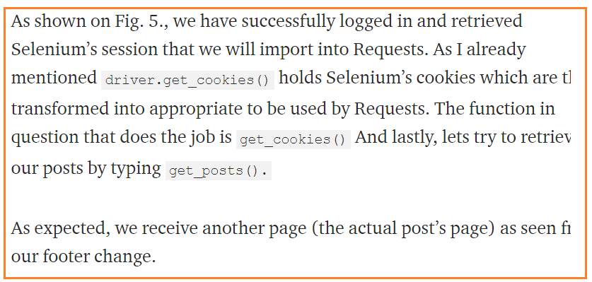

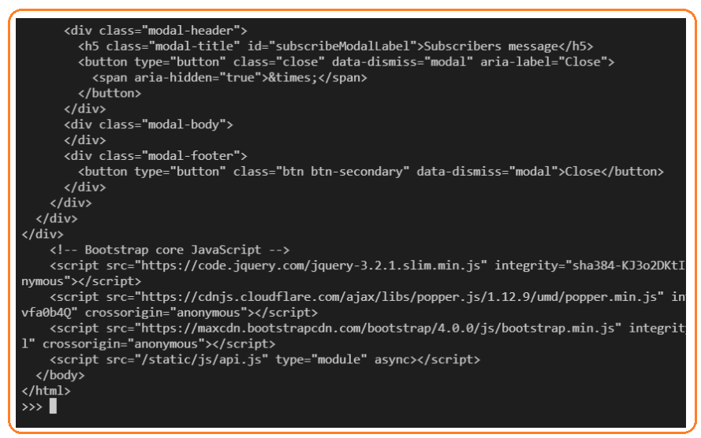

# [Web security: hardening HTTP cookies](https://odino.org/security-hardening-http-cookies/)

14 September 2018

<https://odino.org/security-hardening-http-cookies/>

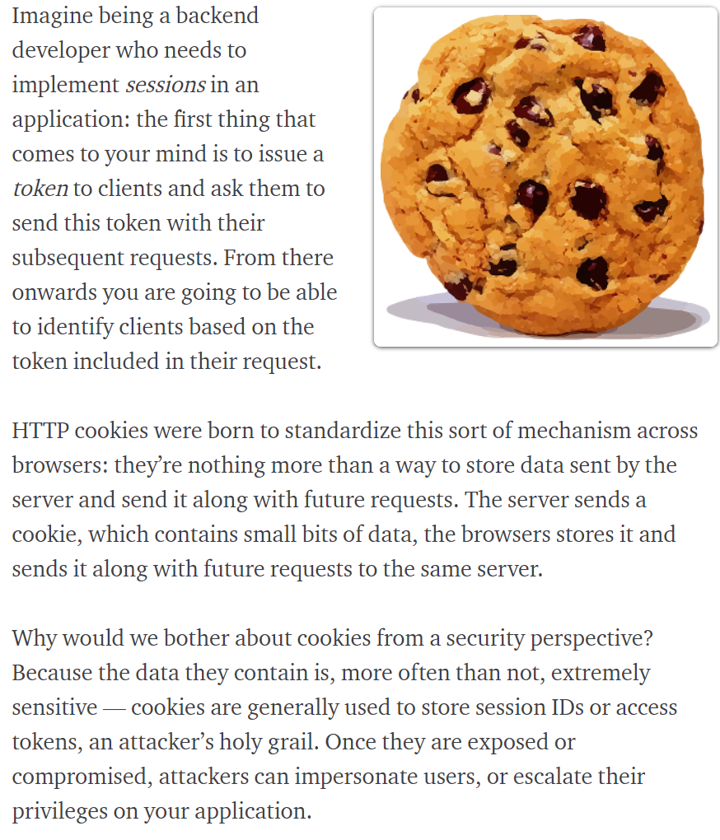

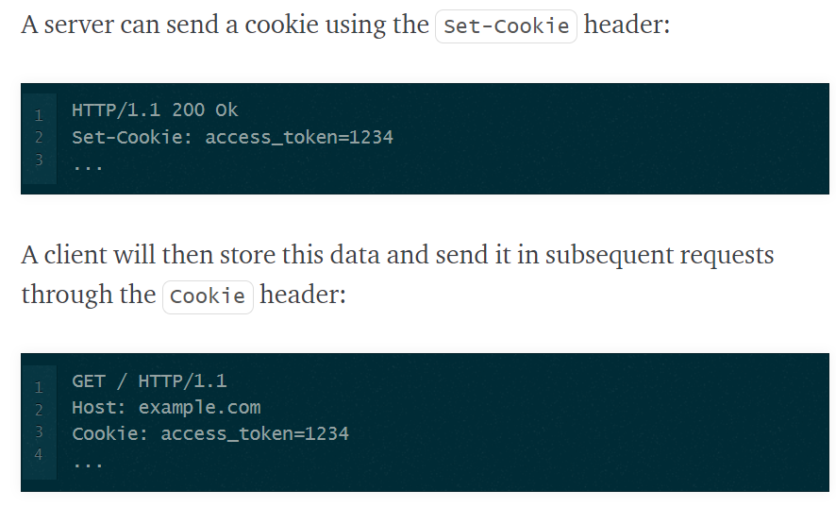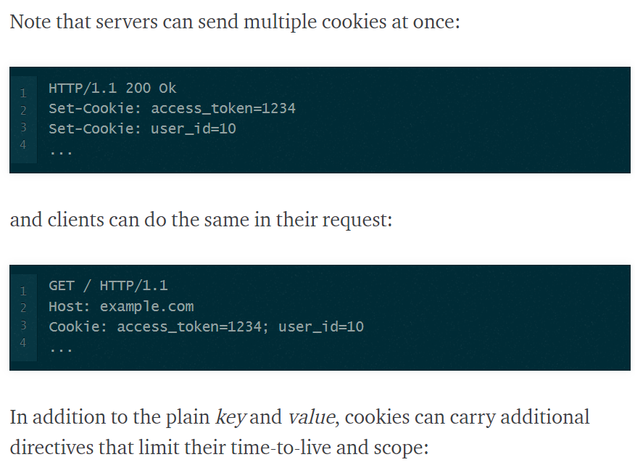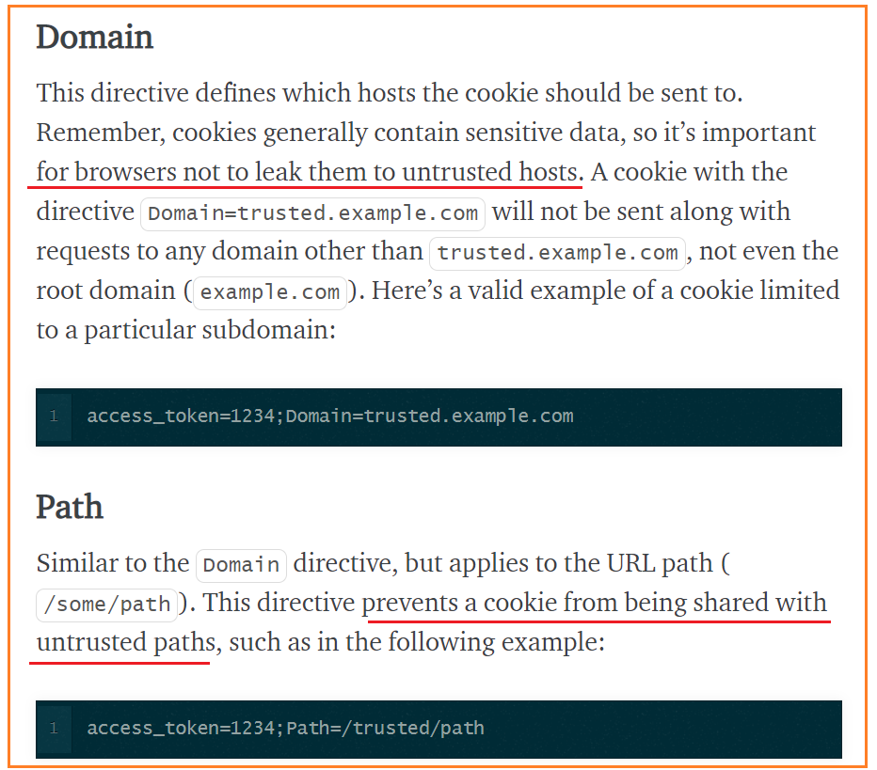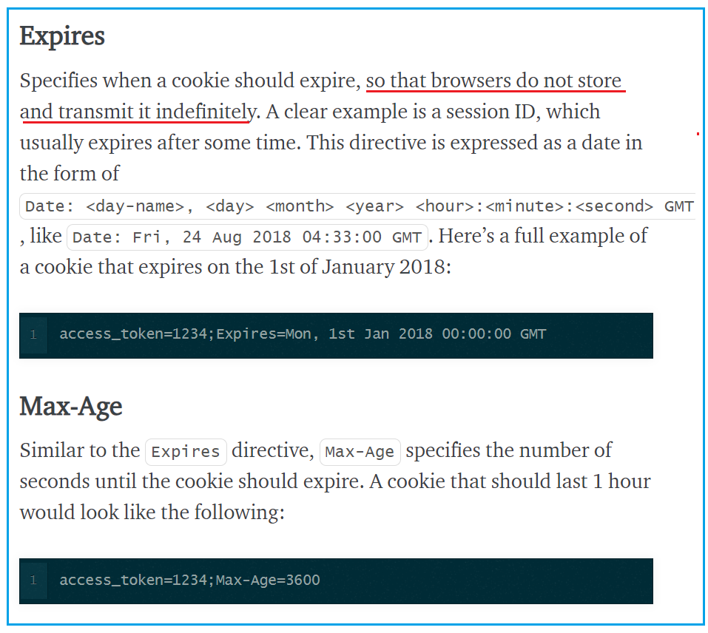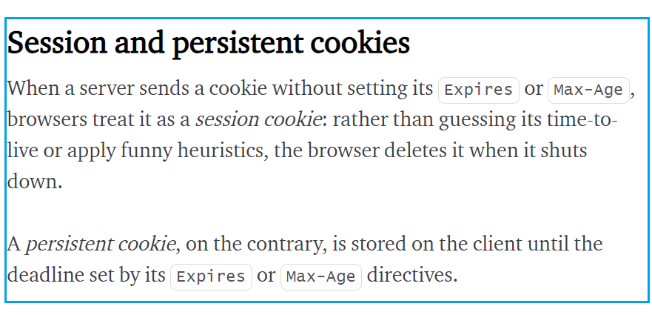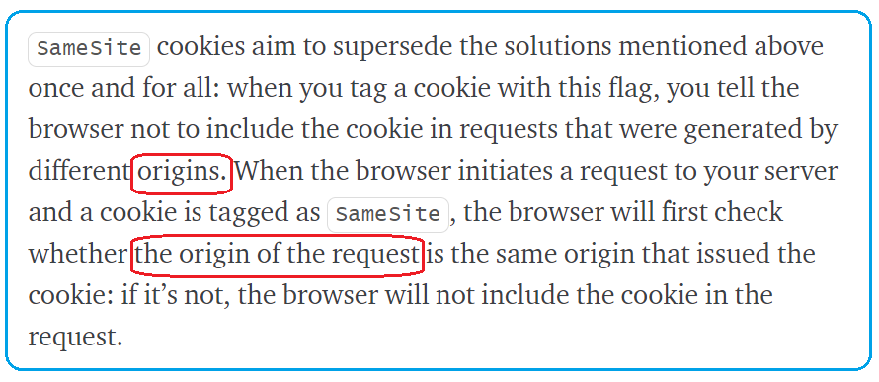

A cookie is a small file sent by a website (or set by a web server) and stored by the end-user's browser. Cookies let us get around the statelessness of the HTTP protocol by storing data at the client-side. Cookies are set using the ***Set-Cookie*** HTTP Header, sent in an HTTP response from the web server. This header instructs the web browser to store the cookie and send it back in future requests to the server. In most cases, a cookie is primarily used as either an authentication token or data storage vehicle.

**The Problem with Cookies**

* Cookies are stored on the client-side and in some cases may contain sensitive data (e.g. an IP address of an internal server or PII) that is set in clear text. Therefore, the cookie data is in complete control of the client; it can be modified or overwritten or captured and reused.
* Cookies are passed over HTTP, and HTTP does not encrypt the headers in anyway. This leaves cookies susceptible for sniffing attacks.
* Cookies are used to store session data. These are known as Session cookies. They store the respective Session ID of the user. The real power of the session happens server side where the Session ID is used to pull data stored on the server that you don't want the client to have access or authorize an end-user for example. Imagine the damage that can be caused when a Session ID is sniffed and replayed again by a malicious attacker via a MITM or Replay attack.

**Identifying your Next Steps to Secure a Cookie**

To identify the security measures you should take to protect your cookie, you should ask yourself the following questions:

* Does my cookie contain any sensitive information? and how sensitive is it?
* Is my cookie passed over TLS? Does it need to persist if the user leaves an TLS portion of the site?
* Does the cookie need to work across different sub domains?
* What part of the my site really need to access my cookie?
* Does my cookie restrict access to Java scripts?

**Protecting your Cookie**

* **Encrypt cookies in the Browser** to protect them at-rest and in-transit. This can be done using a software of Javascript APIs. Encrypting the cookie itself will protect you against:
  + **Session Hijacking**: if the cookie is sent in an encrypted manner, attempts for hijacking attacks will be mitigated in this case, even if the cookies are sent over clear HTTP.
  + **Sniffing Attacks**: in case someone gains local access to your computer and scans for cookies OR someone sniffs your cookie while in-transit, encrypted cookies prevent the attacker from viewing the cookie contents.
  + **XSS Attacks:**in case a cookie gets captured via a cross site scripting attack, the information or data is going to be non-usable in encrypted format or will add a layer of complexity for the attacker to decrypt the captured info.Last but not least,encrypting your cookies in the browser provides you with user privacy.
* **Pass your cookies over TLS** to protect your cookie in-transit.
* **Set the right attributes** for your cookies to secure them and make them safer. Below is a list of attributes that can be set on a per-cookie basis which makes them safer to use:
  + ***Secure:*** informs the browser (or other http clients) to only send the cookie over secure connections (HTTPS or TLS). This means that the cookie will not be available to any part of the site that is not secure, it also makes it much less likely that you will accidentally send the cookie in clear text.
  + ***HTTPOnly:***informs the browser that it should not allow Java scripts to access the content of a cookie. This helps protect against XSS attacks as it will prevent hackers from being able to retrieve and use session or other type of info through such an attack.
  + ***Domain:*** allows you to specify **whether or not to send the cookie to sub-domains**. **NOT Setting** “[www.foo.com](http://www.foo.com/)” for instance will mean only the exact domain “[www.foo.com](http://www.foo.com/)” will be matched, while setting “[foo.com](http://foo.com/)” will also match again any sub-domain (e.g. [support.foo.com](http://support.foo.com/), [blog.foo.com](http://blog.foo.com/), etc...)
  + ***Path:***specifies the location or path the cookie is valid for. For example, the default value of “/” means every request will get the cookie, **while “/services/” would limit the cookie to just that path**. This path is going to be based on the actual URL the browser uses, before any mod_rewrite or URL mapping. It is important when using this attribute to use as restrictive a path as possible to avoid attacks launched from co-located apps.
  + ***Expires:***offers strong protection against misuse of cookies because it erases the cookie when the expiration date is met. If this attribute is not set then the cookie will be erased when the browser is closed by the end-user.
  + ***SameSite***: has been introduced by Google Chrome recently. This attribute offers a robust defense against CSRF attacks when deployed in strict mode, and when supported by the client. It basically requests the browser to only send the cookie in **a first-party** context (**when you are using the web application directly**). When another site tries to request something from the web application, the cookie is not sent. This effectively makes CSRF impossible, because an attacker can not use a user’s session from his site anymore. This attribute might not be supported by Akamai at this point. Please reach out to your account team to confirm.

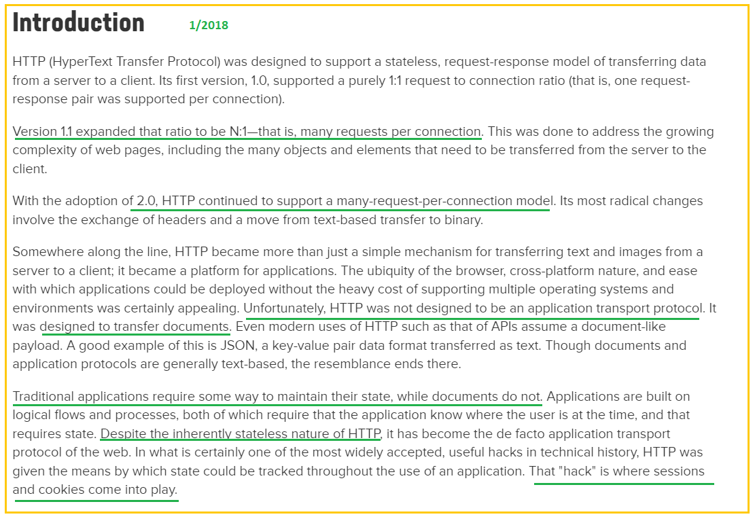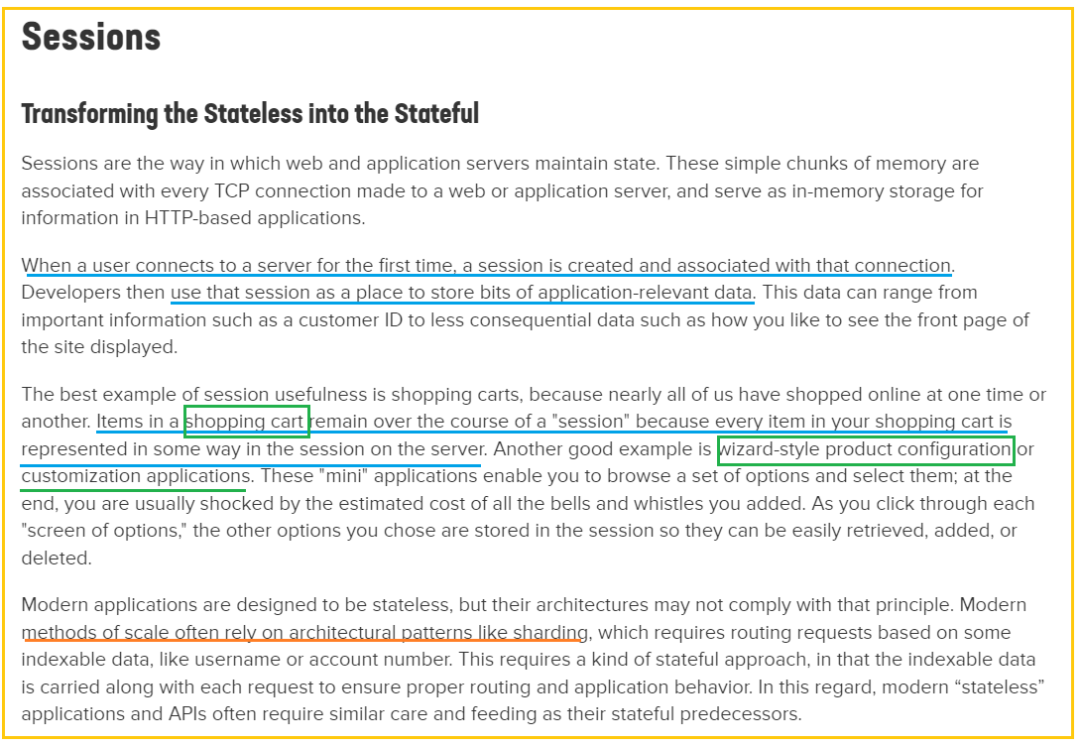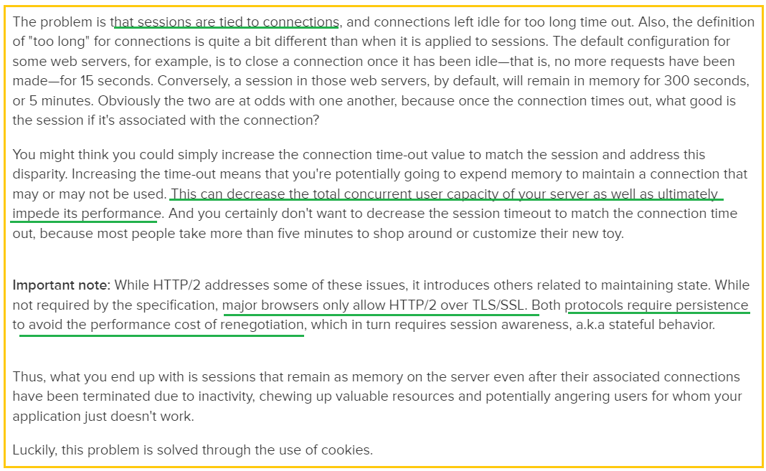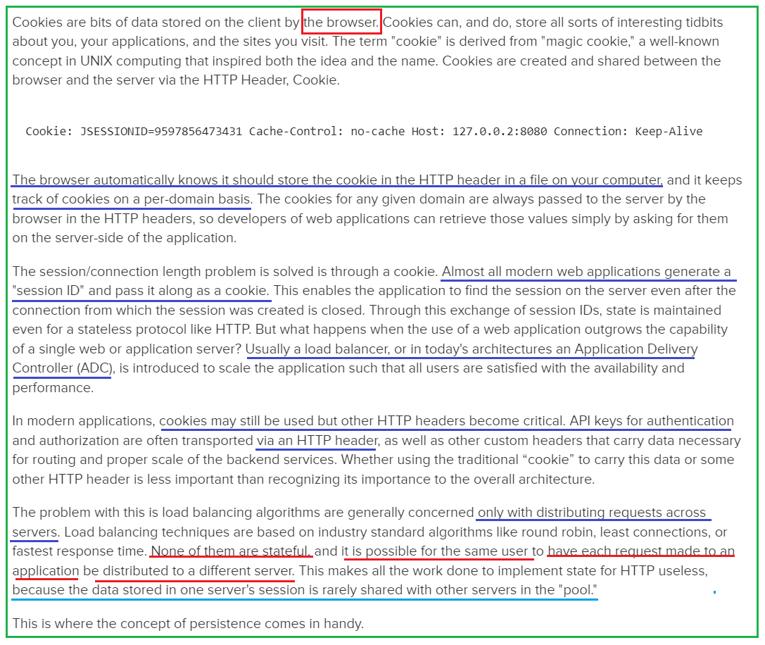

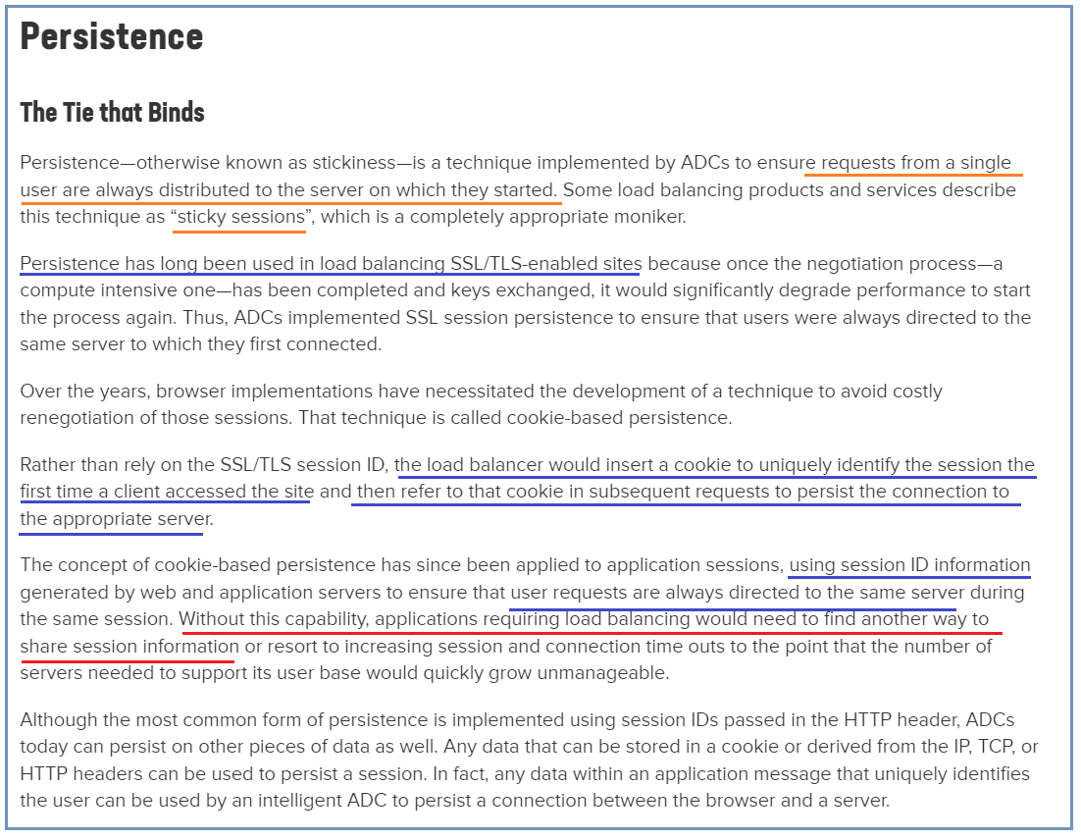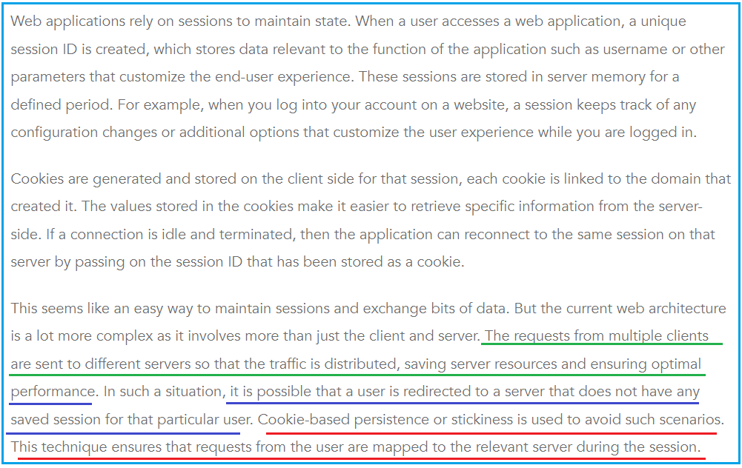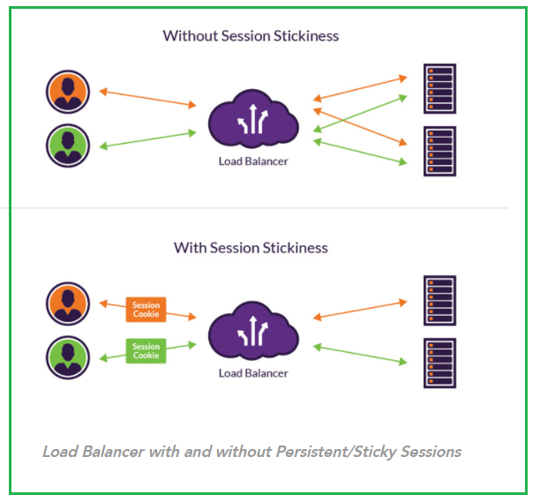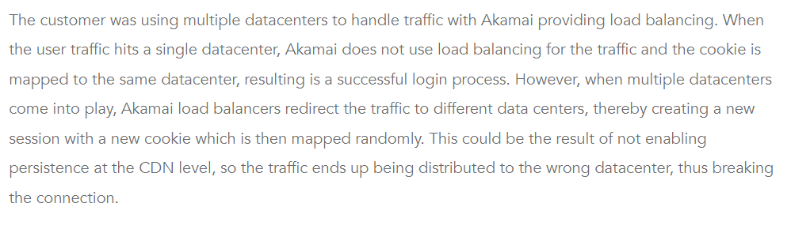

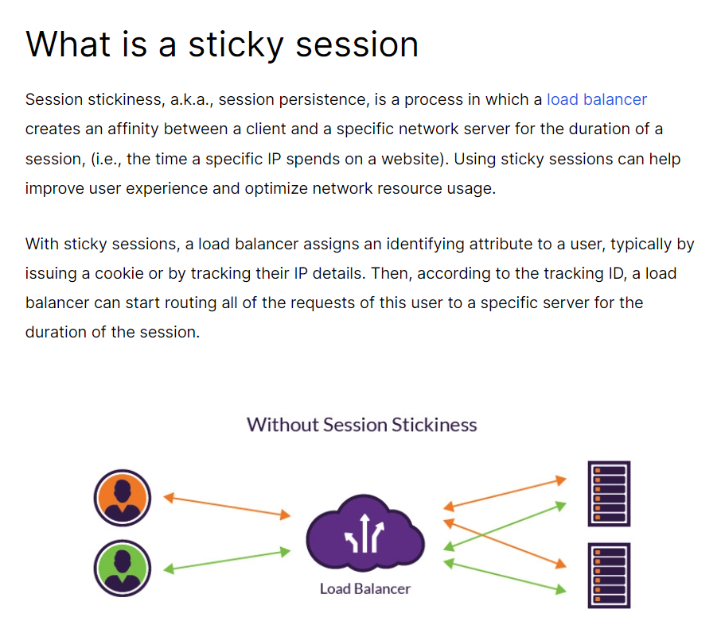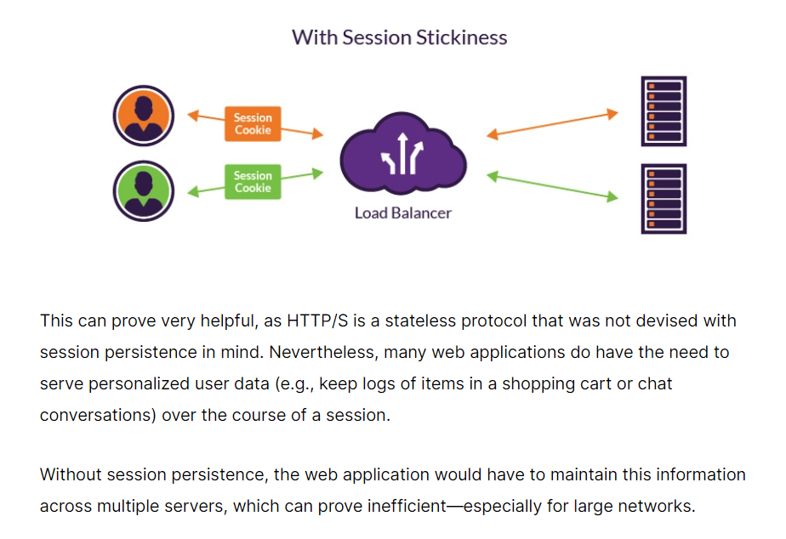

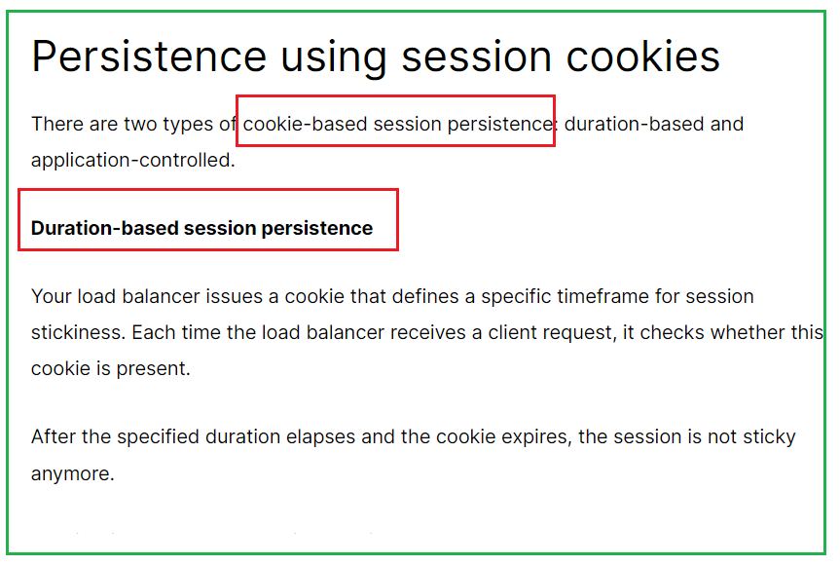

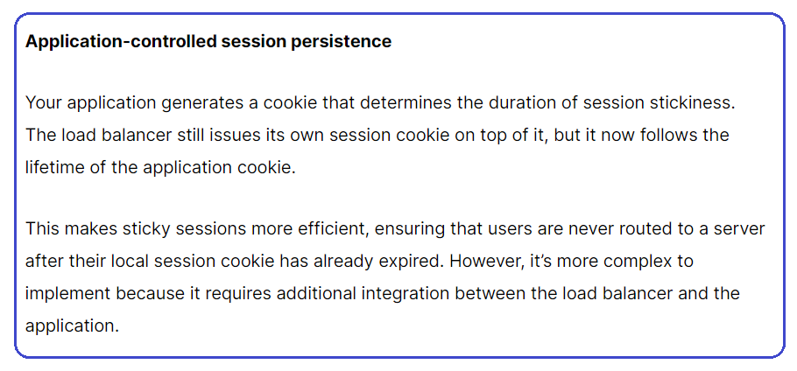 Session Tracking Methods

Last modified on September 7th, 2014 by Joe.

**What is a session?**

A session is a conversation between the server and a client. A conversation consists series of continuous request and response.

**Why should a session be maintained?**

When there is a series of continuous request and response from a same client to a server, the server cannot identify from which client it is getting requests. Because HTTP is a stateless protocol.

When there is a need to maintain the conversational state, session tracking is needed. For example, in a shopping cart application a client keeps on adding items into his cart using multiple requests. When every request is made, the server should identify in which client’s cart the item is to be added. So in this scenario, there is a certain need for session tracking.

Solution is, when a client makes a request it should introduce itself by providing unique identifier every time. There are five different methods to achieve this.

**Session tracking methods:**

1. User authorization
2. Hidden fields
3. URL rewriting
4. Cookies
5. Session tracking API

The first four methods are traditionally used for session tracking in all the server-side technologies. The session tracking API method is provided by the underlying technology (java servlet or PHP or likewise). Session tracking API is built on top of the first four methods.

**1. User Authorization**

Users can be authorized to use the web application in different ways. Basic concept is that the user will provide username and password to login to the application. Based on that the user can be identified and the session can be maintained.

**2. Hidden Fields**

<INPUT TYPE=”hidden” NAME=”technology” VALUE=”servlet”>  
Hidden fields like the above can be inserted in the webpages and information can be sent to the server for session tracking. **These fields are not visible directly to the user**, but can be viewed using view source option from the browsers. This type doesn’t need any special configuration from the browser of server and by default available to use for session tracking. This cannot be used for session tracking when the conversation included static resources lik html pages.

**3. URL Rewriting**

Original URL: <http://server:port/servlet/ServletName>  
Rewritten URL: <http://server:port/servlet/ServletName?sessionid=7456>  
When a request is made, additional parameter is appended with the url. In general added additional parameter will be sessionid or sometimes the userid. It will suffice to track the session. This type of session tracking doesn’t need any special support from the browser. Disadvantage is, implementing this type of session tracking is tedious. We need to keep track of the parameter as a chain link until the conversation completes and also should make sure that, the parameter doesn’t clash with other application parameters.

**4. Cookies**

Cookies are the mostly used technology for session tracking. Cookie is a key value pair of information, sent by the server to the browser. This should be saved by the browser in its space in the client computer. Whenever the browser sends a request to that server it sends the cookie along with it. Then the server can identify the client using the cookie.  
In java, following is the source code snippet to create a cookie:

Cookie cookie = new Cookie(“userID”, “7456”);  
res.addCookie(cookie);

Session tracking is easy to implement and maintain using the cookies. Disadvantage is that, the users can opt to disable cookies using their browser preferences. In such case, the browser will not save the cookie at client computer and session tracking fails.

**5. Session tracking API**

Session tracking API is built on top of the first four methods. This is in order to help the developer to minimize the overhead of session tracking. This type of session tracking is provided by the underlying technology. Lets take the java servlet example. Then, the servlet container manages the session tracking task and the user need not do it explicitly using the java servlets. This is the best of all methods, because all the management and errors related to session tracking will be taken care of by the container itself.

Every client of the server will be mapped with a javax.servlet.http.HttpSession object. Java servlets can use the session object to store and retrieve java objects across the session. Session tracking is at the best when it is implemented using session tracking api.

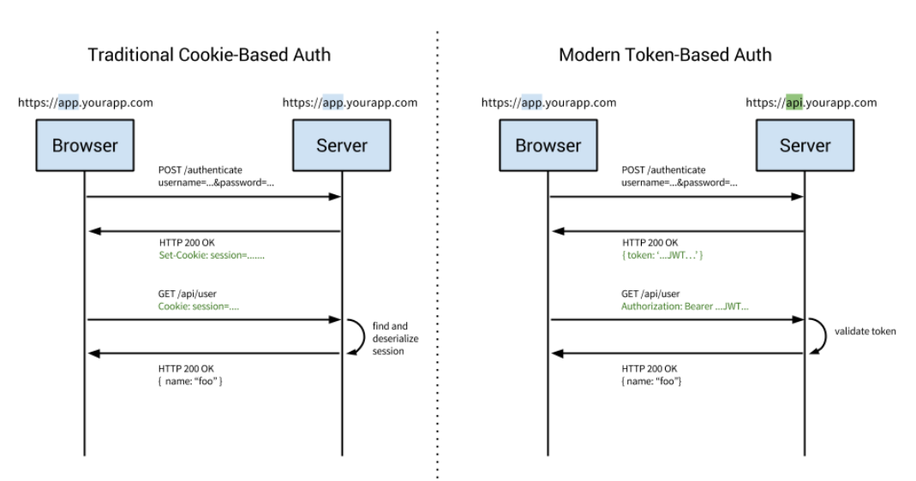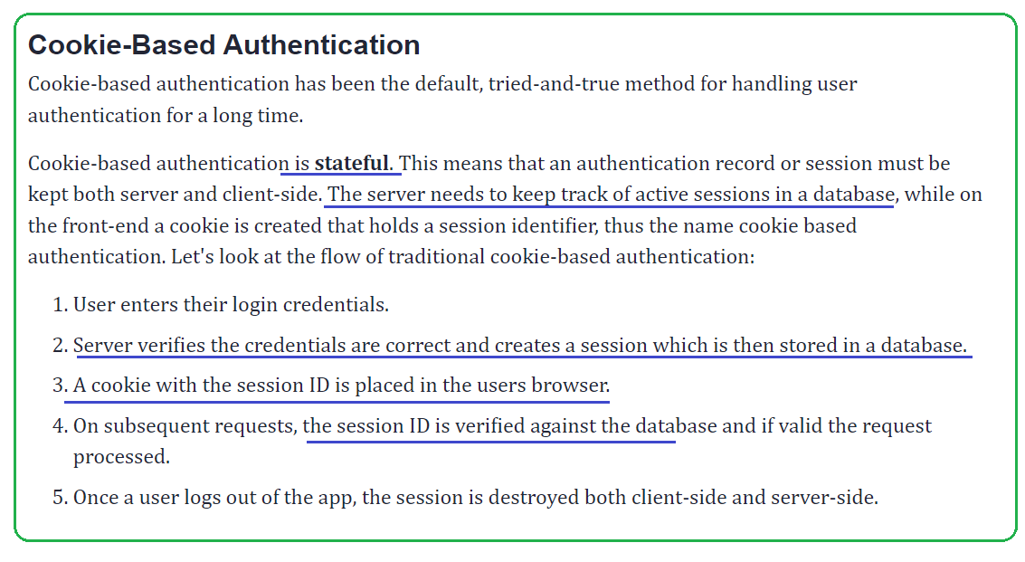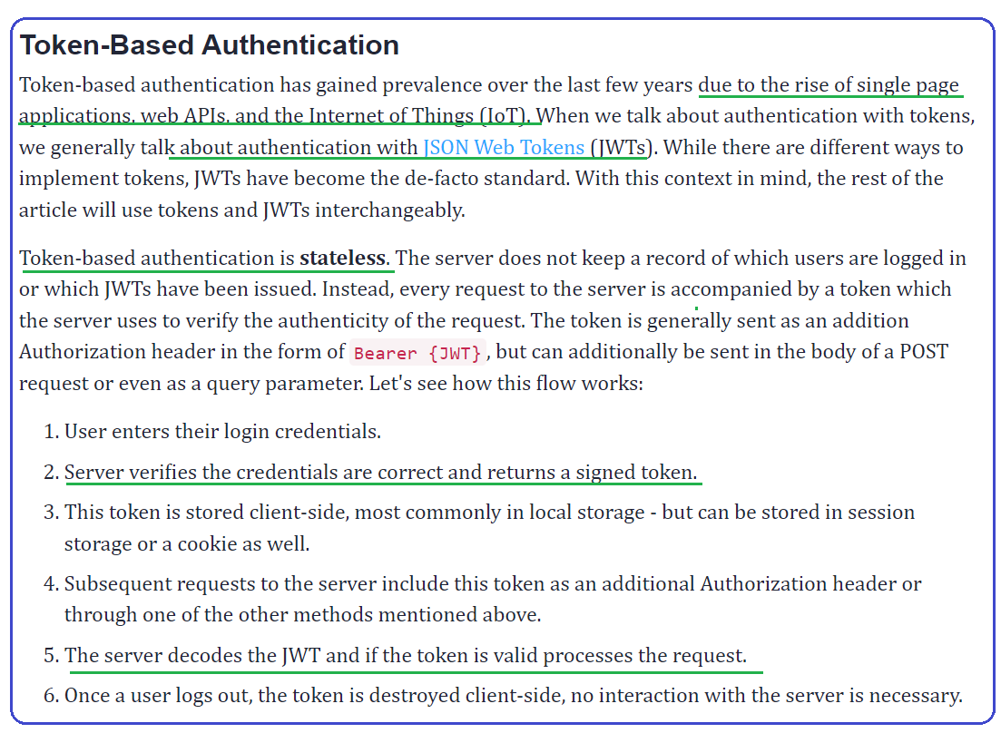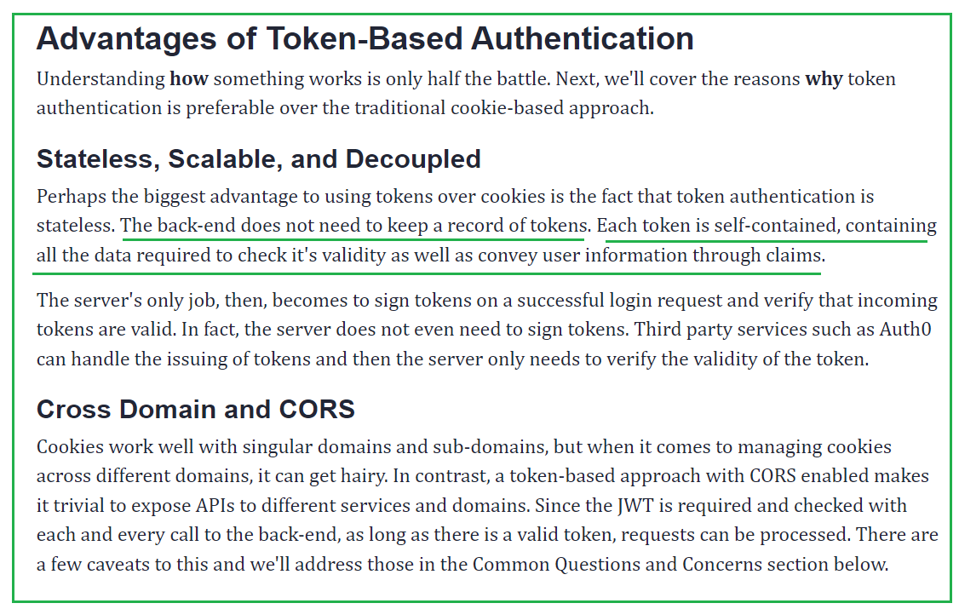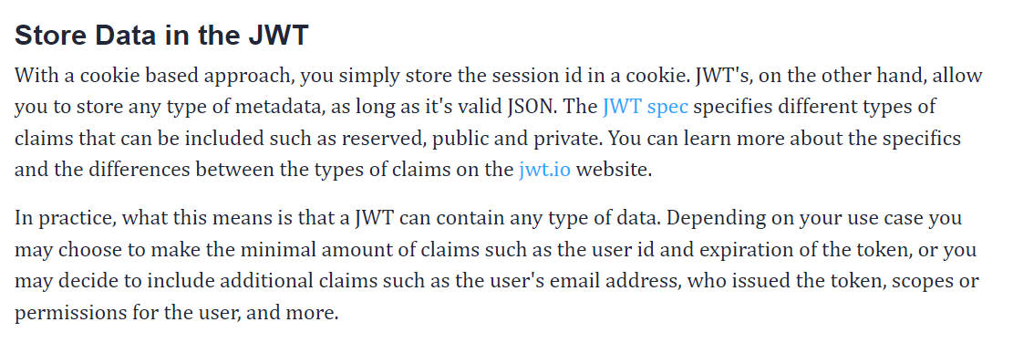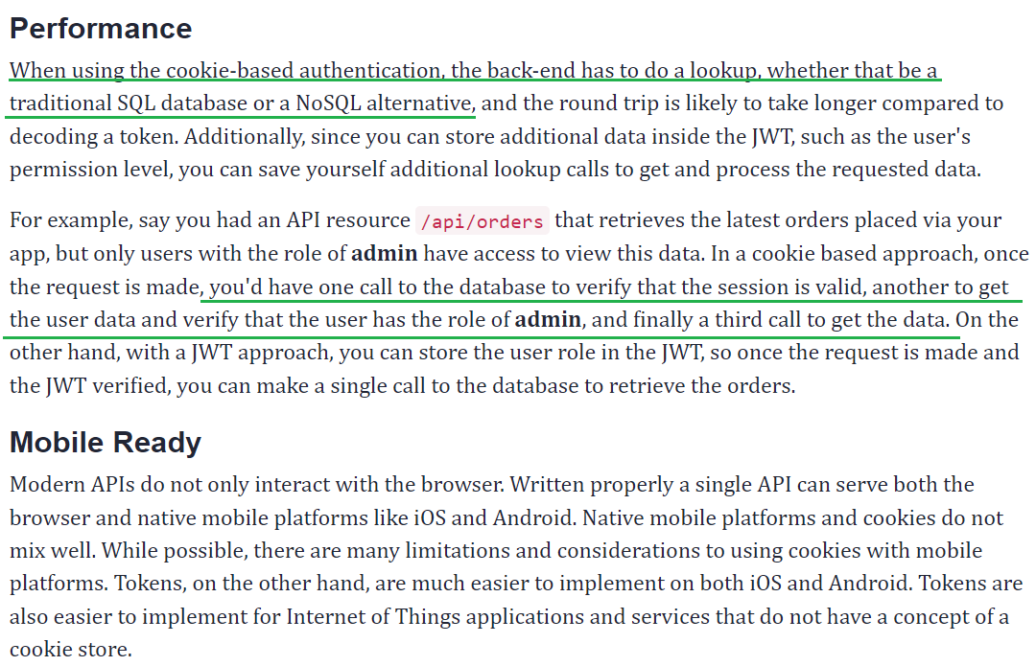

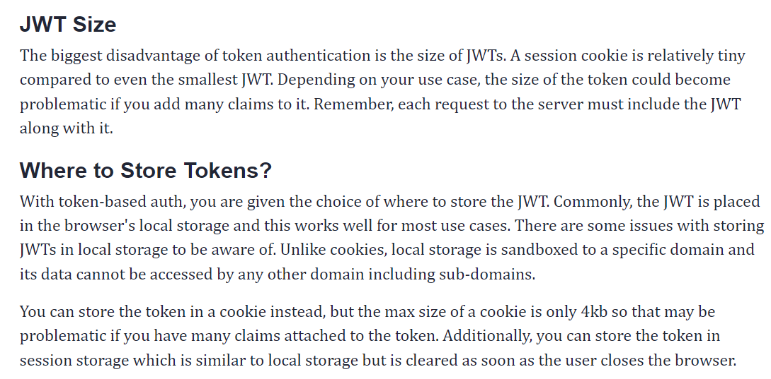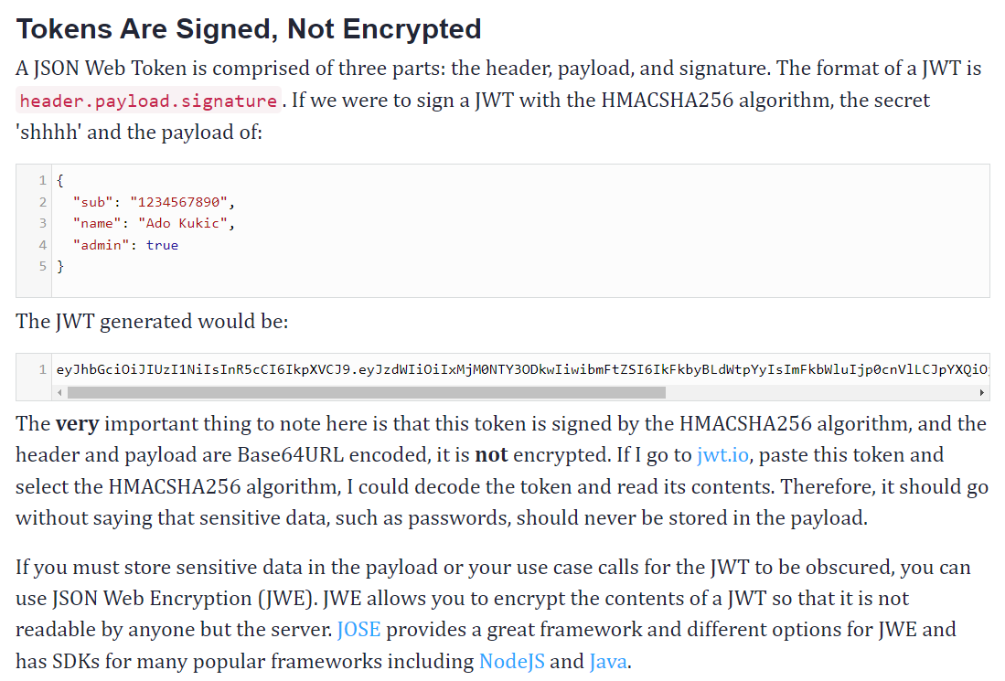

Less important! 10/9/22

1/5/22

**A practical, Complete Tutorial on HTTP cookies**

<https://www.valentinog.com/blog/cookies/>

[**Cookies**](http://il.php.net/manual/en/features.cookies.php) and [**sessions**](http://il.php.net/manual/en/features.sessions.php) are both ways to preserve the application's state between different requests the browser makes.

Cookies

Cookies are small bits of data, (**maximum of 4KB** long), which hold data in a key=value pairs:

name=value; name2=value2

These are set either by [**JavaScript**](https://developer.mozilla.org/en/DOM/document.cookie), or via the server using an [**HTTP header**](http://il.php.net/manual/en/function.setcookie.php).

Cookies have an expiry datetime set, example using HTTP headers:

**Set-Cookie:** name2=value2**;** **Expires=**Wed, 19 Jun 2021 10:18:14 GMT

Which would cause the browser to set a cookie named name2 with a value of value2, which would expire in about 9 years.

Cookies are considered **highly insecure** because the user can easily manipulate their content.

**Cookies are usually used to preserve login state**, where a username and a special hash are sent from the browser, and the server checks them against the database to approve access.

**Cookies are also often used in sessions creation**.

Sessions

Sessions are slightly different. Each user gets a **session ID, which is sent back to the server for validation either by cookie**or by **GET variable**.

Sessions are usually short-lived, which makes them ideal in saving temporary state between applications. **Sessions also expire once the user closes the browser**.

Sessions are considered more secure than cookies because the variables themselves are kept on the **server**. Here's how it works:

1. Server opens a session (sets a cookie via HTTP header)
2. Server sets a session variable.
3. Client changes page
4. Client sends all cookies, along with the session ID from step 1.
5. Server reads session ID from cookie.
6. Server matches session ID from a list in a database (or memory etc).
7. Server finds a match, reads variables which are now available on $_SESSION superglobal.

If PHP does not find a match, it will start a new session, and repeat the steps from 1-7.

You can store sensitive information on a session because it is kept on the server, but **be aware that the session ID can still be stolen** if the user, let's say, logged in over an insecure WiFi. (An attacker can sniff the cookies, and set it as its own, **he won't see the variables themselves, but the server will identify the attacker as the user**).

1. 2011

The concept is **storing persistent data across page loads** for a web visitor. Cookies store it directly on the client. Sessions use a cookie as a key of sorts, to associate with the data that is stored on the server side.

It is preferred to use sessions because the actual values are hidden from the client, and you control when the data expires and becomes invalid. If it was all based on cookies, a user (or hacker) could manipulate their cookie data and then play requests to your site.

**session ID is stored as a cookie on the client machine**, and is then matched up server-side with the session data. The server does not typically control sessions via IP address, rather through a cookie value.

Basic ideas to distinguish between those two.

**Session:**

1. IDU is stored on server (i.e. server-side)
2. Safer (because of 1)
3. Expiration can not be set, session variables will be expired when users close the browser. (nowadays it is stored for 24 minutes as default in php)

**Cookies:**

1. IDU is stored on web-browser (i.e. client-side)
2. Not very safe, since hackers can reach and get your information (because of 1)
3. Expiration can be set (see [setcookies()](http://php.net/manual/en/function.setcookie.php) for more information)

Session is preferred when you need **to store short-term information/values**, such as variables for calculating, measuring, querying etc.

Cookies is preferred when you need to **store long-term information/values**, such as user's account (so that even when they shutdown the computer for 2 days, their account will still be logged in). I can't think of many examples for cookies since it isn't adopted in most of the situations.

**SESSIONS ENDS WHEN USER CLOSES THEIR BROWSER**,

Sessions are stored in a file your php server will generate. To remember which file is for which user, php will **also set a cookie on the user's browser** that holds this session file id so in their next visit php will read this file and reload the session.

**Sessions are server-side files that contain user information, while Cookies are client-side files that contain user information. Sessions have a unique identifier that maps them to specific users. This identifier can be passed in the URL or saved into a session cookie**.

Most modern sites use the second approach, **saving the identifier in a Cookie instead of passing it in a URL** (which poses a security risk). You are probably using this approach without knowing it, and by deleting the cookies you effectively erase their matching sessions as you remove the unique session identifier contained in the cookies

Translating that to Web Servers: The server will store the pertinent information in the session object, and create a session ID which it will send back to the client in a cookie. When the client sends back the cookie, the server can simply look up the session object using the ID. So, if you delete the cookie, the session will be lost.

One other alternative is for the server to use URL rewriting to exchange the session id.

Suppose you had a link - www.myserver.com/myApp.jsp You could go through the page and rewrite every URL as www.myserver.com/myApp.jsp**?sessionID=asdf** or even www.myserver.com/asdf/myApp.jsp and exchange the identifier that way. This technique is handled by the web application container and is usually turned on by setting the configuration to use cookieless sessions.

Cookies and session both store information about the user (to make the HTTP request stateful) but the difference is that cookies store information on the client-side (browser) and sessions store information on the server-side. A cookie is limited in the sense that it stores information about limited users and only stores limited content for each user. A session is not limit in such a way.

1. 2019

The appropriate choice

**Sessions use a cookie!** Session data is stored on the server side, but a UID is stored on client side in a cookie. It allows the server to match a given user with the right session data. UID is protected and hard to hack, but not invulnerable. For sensitive actions (changing email or resetting password), do not rely on sessions neither cookies : ask for the user password to confirm the action.

**Sensitive data** should never be stored in cookies (emails, encrypted passwords, personal data ...). Keep in mind the data are stored on a foreign computer, and if the computer is not private (classroom or public computers) someone else can potentially read the cookies content.

**Remember-me data must be stored in cookies**, otherwise data will be lost when the user closes the browser. However, don't save password or user personal data in the 'remember-me' cookie. Store user data in database and link this data with an encrypted pair of ID / key stored in a cookie.

**Must persistent data remain when the user closes the browser ?**

* If the answer is **yes**, use **cookies**.
* If the answer is **no**, use **sessions**.

**Stateless applications**

* Web application servers are generally "stateless":
  + Each HTTP request is independent; server can't tell if 2 requests came from the same browser or user.
  + Web server applications maintain no information in memory from request to request (only information on disk survives from one request to another).
* Statelessness not always convenient for application developers: need to tie together a series of requests from the same user.

**Browser cookies**

* Cookie basics:
  + The first time a browser connects with a particular server, there are no cookies.
  + When the server responds it includes a **Set-Cookie**: header that defines a cookie.
  + Each cookie is just a name-value pair.
  + In the future whenever the browser connects with the same server, it includes a Cookie: **header** containing the name and value, which the server can use to connect related requests.
* What's in a cookie?
  + Name and data.
    - **Data size limited by browsers (typically < 4 KB).**
    - A server can define multiple cookies with different names, but browsers limit **the number of cookies per server (around 50)**.
  + Domain for this cookie: server, port (optional), URL prefix (optional). The cookie is only included in requests matching its domain.
  + Expiration date: browser can delete old cookies.

**Sessions**

* Cookies are used by the server to **implement *sessions***:
  + A pool of data related to an active connection (one browser instance).
* Typically the cookie for an application contains an identifier for a session.
* Web frameworks like Rails do most of the work of managing sessions and cookies:
  + Rails provides session, a hash-like object in which you can store anything you like
    - Data will be available in all future requests from the same browser.
  + Rails automatically checks for a session cookie at the start of each request:
    - Cookie exists? use it to find session data
    - No cookie? Create new session, new cookie
  + End of each request: save session data where it can be found by future requests.
* Managing session state:
  + Approach #1: just keep state in main memory
  + Approach #2: store session state in files on disk
  + Approach #3: store session state in a database
  + Most frameworks allow you to control session storage:
    - Provide an object that saves and restores session data.

**Cookies vs Cache**

Anyone who browses the internet has heard of cookies and cache. They are messages and memories of who you are, what you did online, what choices you made, how you can be recognized the next time you log in, and how that login can be speeded up. But while the terms are sometimes used interchangeably, they are not identical in form or function.

Let us see what cookies and cache mean.

[](https://kingpinbrowser.com/sponsorship/)

## What is a Cookie?

A browser cookie or simply a cookie is a message. This message is stored in a small file. This file is like your ID.

When you open your browser like Chrome, Safari, or Kingpin and visit a website, the site sends small files about you to your browser which then stores them on your device. This is the website’s way of remembering you (your device) and the actions you performed.

## What is a Cache?

It is an imprint or memory. A memory of some of the elements of sites you visited last. For example, if the site has a video, a cached video will be downloaded on your browser/device. This is the website’s way of quickening the webpage display.

What’s the difference between caches and cookies?  
Caches and cookies look and work differently. We look at the differences:

### 1. Data type

Caches are copies of website data while cookies are information capsules about client behavior. The client here is your machine, not you specifically or anyone else who uses the same device.

### 2. Identification

Cookies, also called HTTP cookies or web cookies are usually text files. Some examples would be your login data, browsing ID, location, your IP address, and the time you spent on them or the information you entered. All cookie files end in .txt and that’s how you identify them.

Caches do not have a single type of extensions. They may be found in the temporary folders on your device and the Settings section on your browser.

The cache includes scripts, graphics, images, animation, GIFs, and audio or video content of websites that you visited the last time. Because these elements are already downloaded on your laptop, the next time you load that site, it would load faster. It would consume less data and would be lighter. The cache is, after all, SRAM (Static Random Access Memory) and it is recalled in a twinkling.

### 3. Storage location and movement

Caches are stored on your device. So are cookies. But follow different types of routes. Site cookies can travel in two directions: from the server to browser and back the same way. HTTP cache travels only in a single direction – server to browser/device.

### 4. Validity

Cookies are erased automatically on some browsers after their expiration date but caches do not. They have to be physically removed.

### 5. Function

Cookies are related to tracking user behavior while caches are related to website loading speed, navigation, easy display, and plugins.

### 6. Size

The cached data vary widely in size. Each page you load sends some memory files over to your browser/device. Since they are copies of web content, they run into gigabytes. Cookies, on the other hand, are fairly tiny, taking three to four KBs on average. But they come in lots.

### 7. Usage

Marketers often use cookies to understand what users like on a site. Based on these files, they show relevant ads to users. So when you log out and come back, cookies are sent back to the server and the site has an Aha moment! It recognizes you and is glad to welcome you back. Even when you are on another site, for example, Facebook or Instagram, businesses still display ads you might like. All based on cookies. And cookies of different sites can interact.

Caches do no such thing. They are simply content to sit on your browser/device and ease the pressure on your server.

## What is the difference between cookies and history?

Browsing history is a register of the number of sites you’ve visited. It also shows the page titles and the time of the visit. Cookies show other facts like passwords or site preferences. Together with cache and auto-fill forms, they form browsing data.

## How cookies and caches work

It’s not all tech mumbo-jumbo. Let’s see how cookies and caches work on something almost all users do – online shopping.

You log into your account. You’re grocery shopping for the month. You look through the catalog and start putting items in your cart. Cookies remember your actions and all the images you checked were made into small bite-sized caches. So when you get back a couple of days later to pay, you find your cart is still loaded and your login is quicker.

## What does [clearing cookies and caches](https://kingpinbrowser.com/blog/best-browser-cleaners/) do?

Experts often suggest that browsing data should be cleared off at the end of a browsing session. [Cookies and caches are likely used to track users.](https://kingpinbrowser.com/blog/computer-monitored/) If you have online privacy concerns, you might want to consider deleting these files when you exit browsing. Saved settings might invite malware and get hackers interested. On the downside, sites may take longer to load and have to figure out your choices all over again.

## Why is it important to clear your cache?

Cache eats into your device storage. It latches on to the RAM and slows down your device. Now although sites load faster your laptop or mobile performs other functions at snail’s pace. Experts recommend clearing off cached or accumulate data regularly to boost up your machine.

Privacy issues may also arise due to the presence of third-party cookies. These files threaten your accounts with a security breach. Your personal and sensitive data is compromised, especially if you perform online transactions with your bank or click on unsuspecting links accidentally.

All major browsers like Firefox or Chrome offer users the choice of manually removing their entire browsing data. While they don’t automatically remove cookies from your device, you can manually visit the cookie folder and delete them.

[Privacy-focused browsers such as Kingpin](https://kingpinbrowser.com/) don’t store any browser history so you don’t have to manually clear it regularly. Also, the Kingpin browser erases cookies automatically as soon as the browsing session is over. If you’re a privacy-conscious user, try a secure browser that doesn’t store your browsing history or cookies.

# What are Cookies?

Cookies are small files that contain information useful to a web site — such as password, preferences, browser, IP Address, date and time of visit, etc. Every time the user loads the website, the browser sends the cookie back to the server to notify the website of the user’s previous activity.

**Cookies have a certain life span defined by their creators and it expires after the fixed time span.**

Cookies often track information like how frequently the user visits, what are the times of visits, what banners have been clicked on, what button clicked, user preferences, items in shopping cart, etc. This allows the site to present you with information customized to fit your needs.

Cookies are usually used to store information needed for shorter periods. Cookies was first introduced by Netscape. In those earlier stages cookies did not receive good acceptance, since rumors said it might hack your personal data. Later people realized that cookies are actually harmless, and now they are highly accepted.

# What are Caches?

A web cache (or HTTP cache) is an information technology for the temporary storage (caching) of web documents, such as HTML pages and images, to reduce bandwidth usage, server load, and perceived lag. **Cache is just a collection of data downloaded to help display a web page.**

A web cache system stores copies of documents passing through it; subsequent requests may be satisfied from the cache if certain conditions are met. A web cache system can refer either to an appliance, or to a software.

For example, when you open websites with large pictures and video’s, it might take some time to load the website. The web browser stores the site contents like the images, videos, audio etc. on your computer. So the next time you load the same website you will find it loading faster.

# What’s The Difference Between Cache And Cookies

Although cookies and cache are two ways to store data on client’s machine, but there are difference between cache and cookies and they serve different purposes.  
• Cookie is used to store information to track different characteristics related to user, while cache is used to make the loading of web pages faster.  
• Cookies stores information such as user preferences, while cache will keep resource files such as audio, video or flash files.  
• Typically, cookies expire after some time, but cache is kept in the client’s machine until they are removed manually by the user.

## What is the Browser Cache?

In general terms, “caching” something means temporarily storing it in a spot that makes for easier/faster retrieval.

There are a lot of different ways that you can cache your WordPress website, but we’re obviously focused on one specific implementation – the **browser cache**.

Let’s start at the beginning – your site has a lot of static files that won’t change visit-to-visit. One common example is your site’s logo. You probably won’t change your logo that often, and your logo is likely the same on all or most of your site.

So let’s say a visitor views three separate pages on your site – it would be a waste to force that visitor to download the exact same logo file three times in a row, right?

The browser cache lets you avoid that situation by storing these static files on a visitor’s local computer. So with the browser cache, it would work like this instead:

* **First visit**– the visitor’s browser downloads the logo file from your server and saves it locally in the browser cache.
* **Second and third visits**– the visitor’s browser loads the logo from the visitor’s local storage (the browser cache), instead of downloading the logo again.

And as a result, your website loads faster, which is a great thing.

To control how long a visitor’s browser stores certain types of files, you can set expiration dates. For example, you can tell a visitor’s browser “store all JPEG images for 4 months, but only store MP4 videos for 1 month”.

Additionally, if you do need to change a file before the expiration is up (like your logo), you can employ a technique called [cache busting](https://www.keycdn.com/support/what-is-cache-busting) to force visitors’ browsers to download the most recent version of a file.

Because browser caching is a great performance tip, WP Rocket automatically adds browser caching to your WordPress site as soon as you activate the WP Rocket plugin. You can [learn more about this feature here](https://docs.wp-rocket.me/article/80-browser-caching).

## What is a Cookie?

According to the dictionary, a cookie is a “small sweet cake, typically round, fl”…wait, that doesn’t sound right.

Let’s try again…

A cookie is a small file that’s stored on a visitor’s device and contains data specific to a particular client. “Client”, in this case, just means the device of the person who’s visiting.

Cookies help you store useful information about a visitor, like their login information/authentication so that they don’t have to manually log in each time, or the items in their shopping cart. Or, you can also use cookies to track and identify visitors, even between different website visits.

Cookies are only used to store text-based data, like IP addresses, session IDs, visit histories, etc. – you can’t use them to store an image, as the browser cache allows for.

Additionally, unlike a browser cache, which is a one-way transfer (from the server to the local cache), a client’s web browser will send the cookie to your web server on each visit – so the information can go from both:

* Server → client
* Client → server

There are two types of cookies:

* **Persistent cookie**– though this type of cookie has an expiration date, it stays on a visitor’s local machine while active and “persists” between visits to your website. It lets you identify a visitor even if they leave your site and come back.
* **Session cookie**– this type of cookie is stored in memory and never saved to your visitor’s local machine. It’s active during a visit, but as soon as your visitor closes their browser, a session cookie is permanently gone.

## Browser Cache vs Cookies: What Are They Used For?

At this point, you probably have some idea about the difference in use between the browser cache vs cookies, but let’s cover the point in a little more detail to make sure.

**Browser cache** lets you store certain static files – including images, videos, CSS/JavaScript, etc. This is a one-way relationship – those files don’t communicate back to your server once they’re stored. Additionally, the browser cache doesn’t identify specific users – it treats all users the same.

The browser cache helps you **speed up your site**and lessen the load on your server – that’s all it’s used for.

**Cookies** **are small text-based files** that let you track, identify, or otherwise store information that’s unique to each visitor. This is a two-way relationship, where your server is able to read the information from the cookie.

Cookies help you provide a better user experience, like recognizing that a user is logged-in or identifying a visitor to show them the items in their shopping cart at an eCommerce store.

Or, cookies can help you track and identify specific visitors, like setting a cookie so that you don’t display an email opt-in popup after a visitor has already subscribed to your email list.

Finally, you can even use cookies to help with off-site functionality. For example, setting a retargeting cookie so that you can display ads to your site’s visitors even when they’re on other sites.

